Adam Fox

1704760

Supervisors Daniel Karapetyan and Adrian Clark

Second Assessor Morteza Varasteh

Weather Based Routing Application

CE601 - Digital Technology Solutions Degree Apprenticeship

# Acknowledgements

I want to thank Derivco for sponsoring this apprenticeship scheme, allowing me to take this course. I also want to thank everyone at Derivco for always being friendly and helping me with any questions I have. I know I have become a better software developer due to this input.

I want to acknowledge the teams I have rotated through in the past 3 years. Everyone was always willing to help, was fun to be around and helped me learn on and off the job skills. Being part of the three different departments really helped expand my knowledge, learn new languages, learn to implement different practices, and led to the improvement or introduction of many skills. Thanks to Blue Team in Services, Flamingo in Dashboard, and the Games Team in Client.

Thanks for the 3 other apprentices Amie Johnson, Ross Baker and Ryan Barry for working alongside me during the apprenticeship scheme. Helping me to learn from, and enjoy, the experience more.

# Abstract

This project is a three-tier architecture application with a user-facing website, based on the 300-hour timescale of this module. This application performs routing and weather-based calculations and then shows this information to the user in a graphical and interactive way. After the creation of a route, quick weather, departure, and elevation information will be provided to quickly inform the users of upcoming weather and terrain. More in depth information is then presented to provide an insight of more detailed values. There are few resources I can find online that provides both routing and weather information in one place. I find none where the weather information is accurate enough where the values are based on the journey the user will take.

This application is designed for pedestrians or cyclists who want routing and weather information based on an upcoming journey, the likeliest use of this would be to avoid rain, which is especially useful information to know in England.

Alongside the Angular based frontend is a .NET Core Restful API which manages communication between the frontend, the external APIs used for data retrieval, and the database I have generated. This database holds business logic and data manipulation of the tabled data.

Contents

Project Aim 1

Project Objectives 1

Context 3

Sustainability 3

Legal 3

Ethical 4

Intellectual Property 4

Technical Achievements 5

Languages 5

Testing 5

Frontend 6

Components 6

Alert 6

Elevation Info 7

Graph 10

Icon Text 13

Login Modal 14

Map 16

Weather Modal 21

Navbar 23

Route Creation 24

Route Data Table 29

Models 31

Elevation Info 31

MyChartOptions 32

RouteInformation 32

Services 33

Assets 33

Backend 34

Database 34

Why I Chose the Three API Providers 35

Package Management 36

Clean Coding 36

Responsive Design 37

Problems I Overcame 37

Project Management 38

Agile 38

Jira 38

Maintaining Momentum and Adapting to Change 40

Version Control 40

SQL Change Automation 40

Commit Messages 40

Risk Management 41

Reflection 41

Conclusion 42

# Project Aim

The aim of this project is to provide routing, elevation, and weather information of user defined routes in an interactive and graphical way. This information will be designed to best inform users of an upcoming route so they can plan accordingly.

# Project Objectives

In order to achieve this aim, I will allow the construction of routes by the user. These routes will be created by requests to TOMTOM API and the visual displayed by the google maps JavaScript API.

Routes can be created by providing a name, travel mode of either cycling or walking, starting point and destination. This starting point and destination can be generated through the map being clicked, search of name, or search of latitude and longitude values.

Routes should be highlightable and be graphically focused on when highlighted or created. Markers and rain intensity indicators visibility will be togglable.

Elevation information will be shown of each route. This information will include a descriptor of the difficulty of the route, the elevation change, max incline, and a graph visually showing the elevation along the route. This information will be selectable where map elements are added to better portray this information on the map.

Weather and routing information will be calculated or retrieved from the API. Weather markers must be calculated to be placed equidistance apart and weather information must be collected on these points, the timing of the data must match the time when the user taking the journey would be present at that location.

The user’s location will be viewed on the map on opening of the webpage if location privileges are accepted by the user. If not, a default boundary will be set of mid-England.

Rain intensity indicators will be placed at each weather point, the size and colour will match the rain intensity at that point.

Route and quick weather information will be viewable from a table. This table will allow for the addition and removal of routes. This will include weather descriptors for each departure time providing quick weather information to the user.

Routes will have functionality to be favourited, if favourites the route will be saved to the database where the route will be accessed on the user re-entering the website. Deleting a favourited route or unfavouriting a route will remove the route from the database.

Each route will have a model that displays weather information in detail. Current weather will be provided. Rain intensity and probability of the route at each departure with be graphically displayed. A second graph showing the average rain intensity of all the routes will be generated. This graph will highlight the currently viewed route and will compare to the rest. This graph can be configured to compare values of different departure times.

Login functionality will be added. Allowing for users to log in and out and favourite routes.

Once all these objectives are complete, I will have finished the project and managed to complete to the first standard I would want and is expected for 300 hours.

# Context

Nobody likes being caught out in the rain, what this application does is consolidate routing and weather information in one location. In other applications that provide weather information, this information is usually a generic description of a single place and time. What my application does is provide minutely rain information so I can tell the user exactly how much rain will hit them at a certain point in the route. I can also inform them how the route’s weather would change if they were to progress through the journey, or if they were to leave at different departure times.

This is an important problem to solve as getting stuck in rain can really negatively impact your mood.

This program will not be a life changer, there are still national broadcasts and google maps to provide very professional products. What my project does provide is a place where both these aspects of information are combined. I have not found another application that tells the user minutely rain information along a route, it is always a broader and more general weather definition. This product’s role in society could be as an ease of use product to best plan upcoming travels.

## Sustainability

From an environmentally sustainability standpoint. This can be said to promote walking and cycling. It is getting people to avoid using their cars by informing the users how an upcoming route ahead will change. The program could state that it is heavily raining now, but in 10 minutes the rain will disappear. This could persuade someone from not leaving now in car, but to wait and walk instead. The reduction of car usage will cause less pollution to be generated.

From a business sustainability standpoint, the weather and people’s willingness to best act against it will never disappear. I could see this application, if it was to go live, to be used by people not just now but far into the future as it provides a product that will never be diminished, knowledge of routing and the relating weather.

## Legal

GDPR is an important legal process to be compliant with. GDPR laws oversee the protection of user sensitive data, if this product were to go live, I would need to demonstrate that user sensitive information was being stored to a level deemed safe enough. As you can add a route like “Home to work” this could tell a person with malicious intent, information such as where someone lives and works. To improve the security of my application, I use well respected authorisation and security methods such as JWT token authentication and data hashing. During development of this project, I have the database hosted on my machine. This breaches GDPR as I could theoretically view all the details that are entered. If this program were to go live, I would need to use a professional database staging product that complies with GDPR.

As I am using APIs provided by companies to retrieve data, I need to make sure that I am not in breach of their terms and conditions. One simple example is that Dark Sky provides 1000 requests before you have to start paying. If I were to create a system where I signed up for multiple accounts and used these keys on one website to avoid the request cap, I would be breaking their terms of service for actively trying to avoid the capped request count. Another example is that I cannot blatantly say that I am the one who coded the google map GUI or that I generated the weather data. If I were to try to sell this information onwards this would break terms of service as I am provided someone else’s work as my own and taking ownership of the data or code.

## Ethical

Ethically this program provides no ethical dilemma. Like previously mentioned, it promotes people to take a walk or cycle rather than taking the car, helping promoting exercise and the enjoyment of spending time outside. People may be more inclined to go outside if they are provided with information that my project can provide. This project is not taking advantage of people and I am only promoting healthy actions. All the data I have received are from professional sources where the data is collected legally and ethically.

## Intellectual Property

The respective companies have intellectual properties over their APIs however I have intellectual property over my application. Even though being an apprentice, I own this program as I worked on this outside of work hours (that I am entitled to take by law).

# Technical Achievements

I have managed to achieve a lot and I am proud of the application I have produced. This coursework is defined as 300 hours and I believe that what I have made is of high quality for this module’s timescale.

To go through all of the technical achievements I will go through each tier of the three-tier architecture program, starting with frontend, progressing to backend, and finishing on the database. As the frontend application is the largest, I will go through each component to describe what I have achieved. This report will contain what I have produced and what the application provides functionality-wise. Technical Details will be present on the corresponding GitLab project.

Frontend - <https://cseegit.essex.ac.uk/af17923/weatherroutingfrontend>

Backend - <https://cseegit.essex.ac.uk/af17923/weatherroutingwebapi>

Database - <https://cseegit.essex.ac.uk/af17923/weatherroutingdatabase>

## Languages

There are many languages I had to use for this coursework. The introduction of multiple languages alone increases the complexity of the application. The knowledge then needs to grow to not only cover the foundations of the languages, but to do the advanced processes and code in a clean way. This is a large technical achievement in its own right. These are described on the technical documentation (<https://cseegit.essex.ac.uk/af17923/weatherroutingfrontend>).

## Testing

I have performed manual and automatic testing on the application. Information about testing is present on the frontend technical documentation under general technical achievements (<https://cseegit.essex.ac.uk/af17923/weatherroutingfrontend>).

## Frontend

For the website I decided to use the Angular Framework. I chose to use this framework for many reasons, most notably the componentisation programming style I enjoy programming in. Other reasons include the dynamic setting and querying of html elements, subscription model and the use of typescript which is a strongly typed language. I had also worked with this framework before whilst working in the apprenticeship team and also in the Dashboard department.

### Components

#### Alert

This component works on a subscription model. It subscribes to the “alertService” service, it will display a success, warning, or error alert.

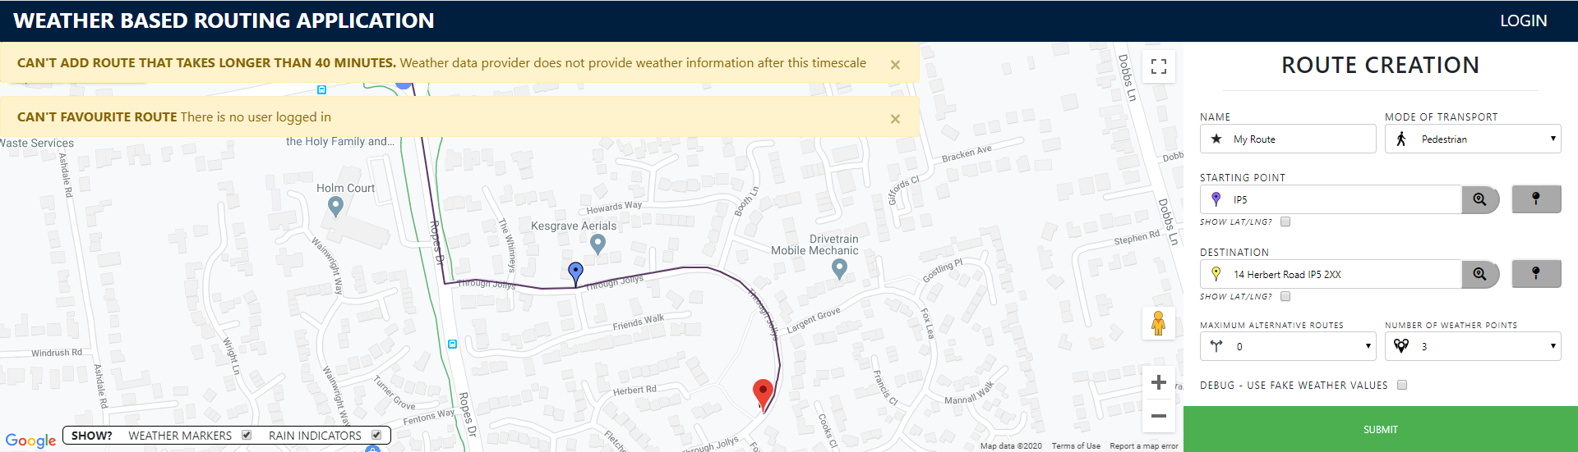

*This shows two alert warnings. One was for a route that was going to take longer than 40 minutes. The other was that the user tried favouriting the route without logging in prior.*

Easy Use

All that is required from a component to use this is to have the alert service and perform this.alertService.warning(title, description);I am really happy with this solution as it is easy to use, confides the alert code to one component whilst having it be triggerable in any component due to loosely coupling service dependency Injection.

Functionality

These alerts are removable, and the functionality is provided by bootstrap as I was experimenting with what this would provide me, the only other place bootstrap is used is to create the modals.

#### Elevation Info

This component shows elevation relating information of a selected route.

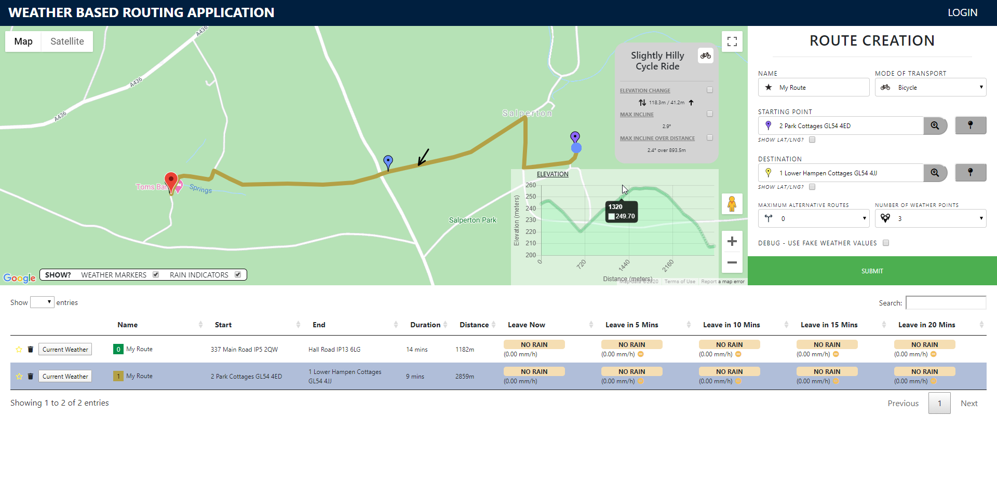

*Showing the elevation of this route. Notice how when hovering over the graph I can see the latitude and there is a graphical pointer to show where in the route this latitude is set.*

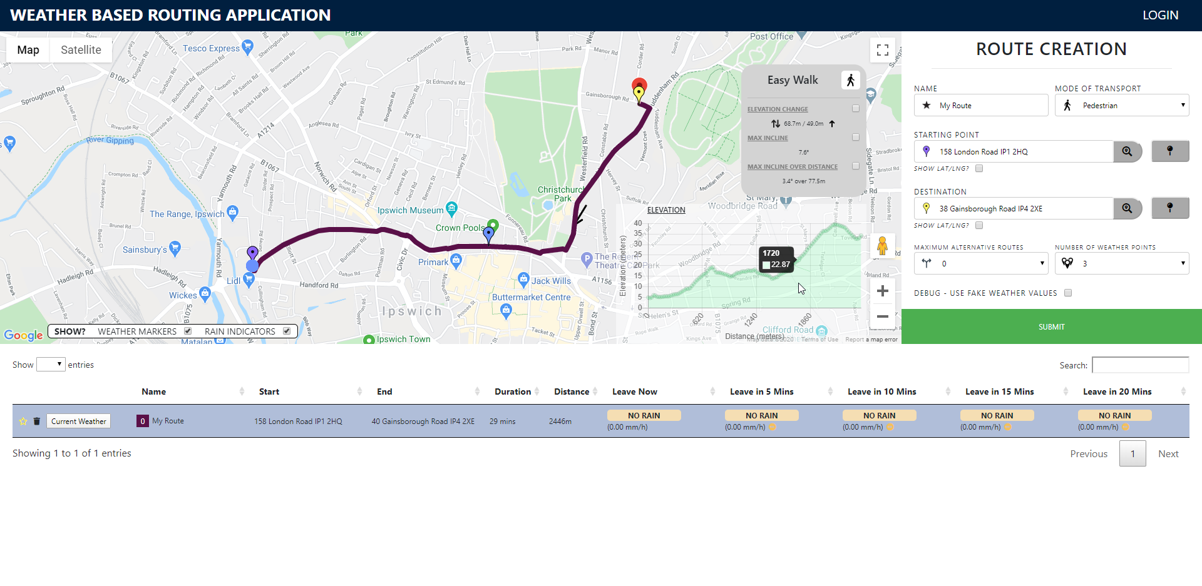

*Another example of elevation being shown on a route in Ipswich.*

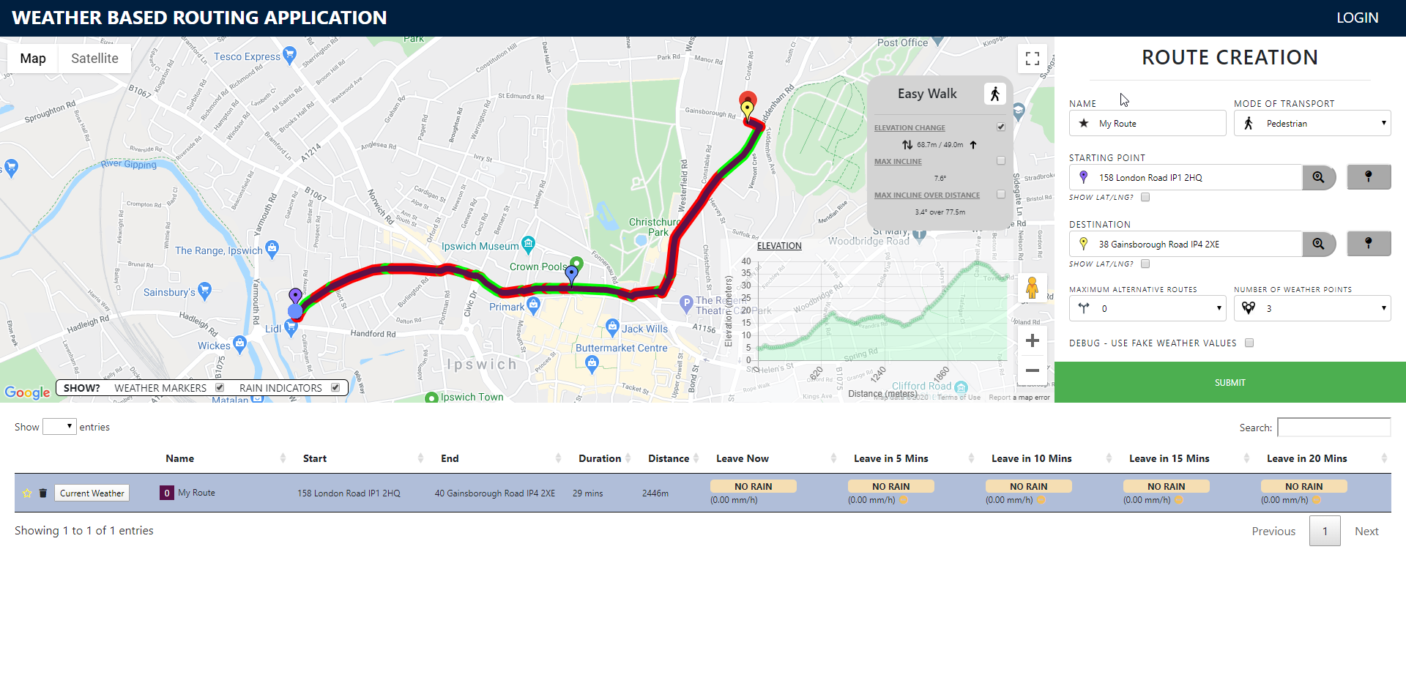

*This is showing the underlay showing the elevation change. A red underlay for an increase in elevation and green for a decrease in elevation.*

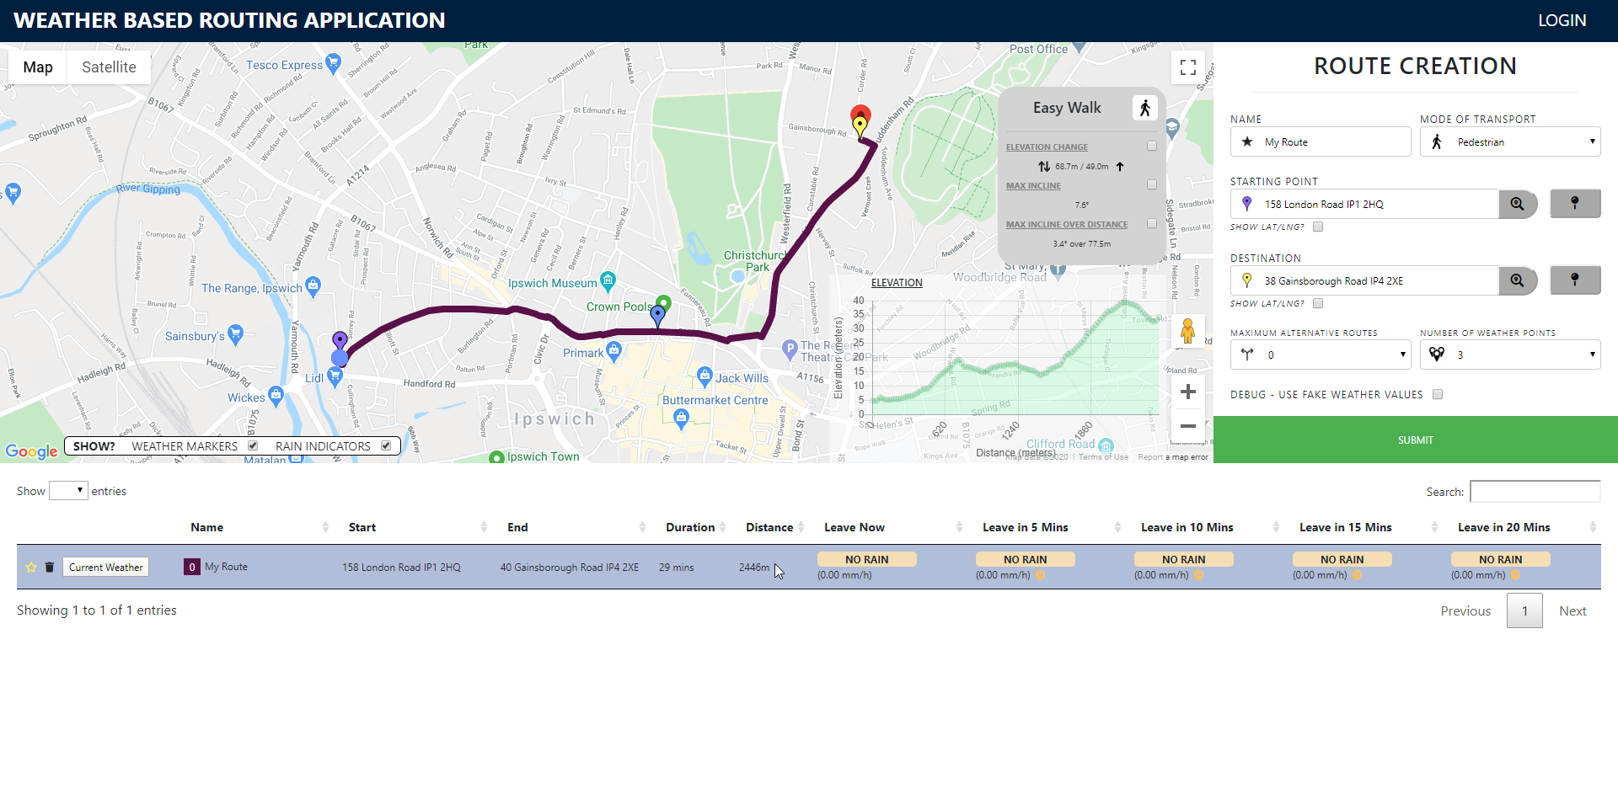

*Here I unhighlted the route and chose it again, you can see that the GUI has been remvoed and the checkboxes defualt to their hidden state.*

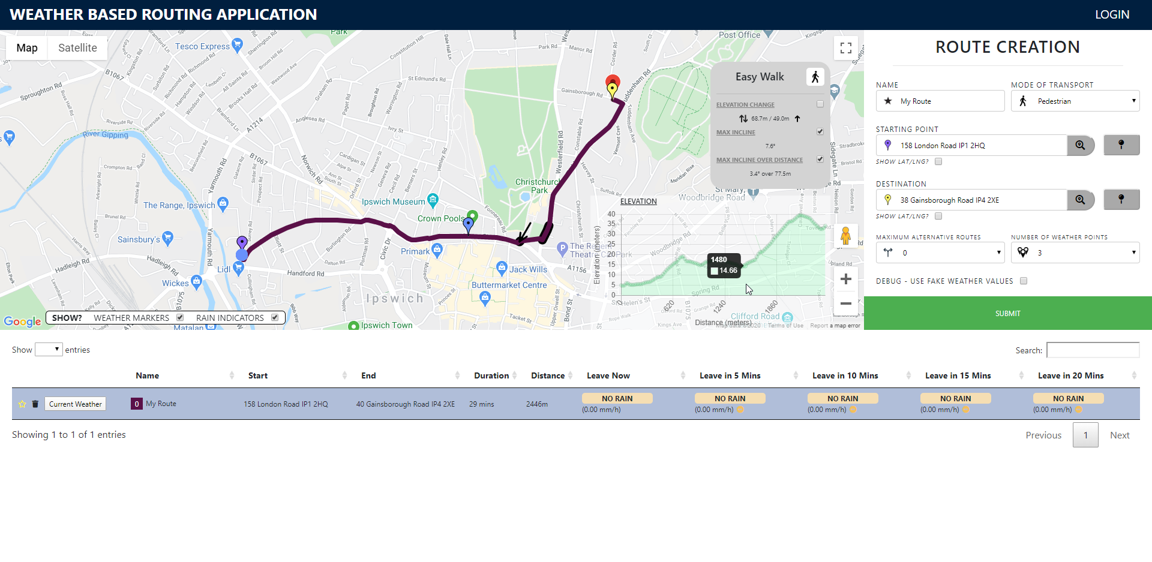

*Here shows the underlays for max incline, this is the black underlay that is being pointed to and hovered over on the graph. The larger underlay shows the max elevation of a continous positive incline.*

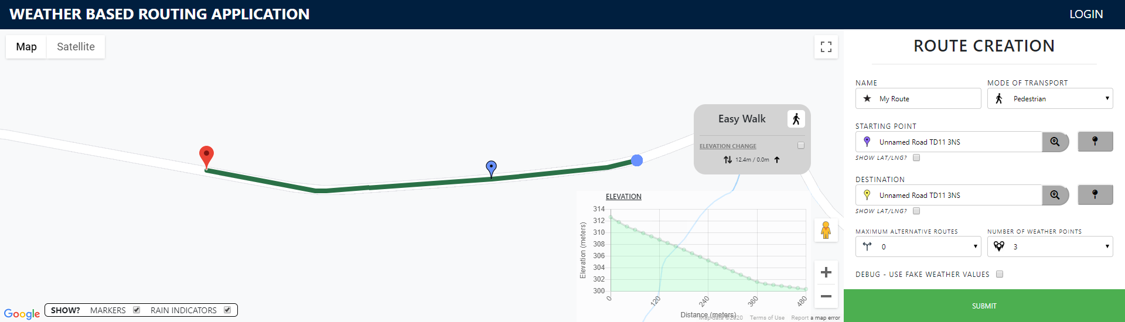

*See how only elevation change is shown. The other information relating to positive incline are not present due to the fact there is no positive incline in the route.*

Route Descriptor

The top of the component displays a descriptor of the difficulty of the route and has an icon to show which travel type was used in the creation of the route.

Elevation Information Being Shown

The following information is shown.

* elevation change. The first value being the total elevation change along the route whilst the right most value shows the positive incline.
* Max incline. This is the maximum incline angle between two legs in the route.
* Max incline over distance. This is the maximum incline angle of a continuous incline. this also includes the distance that this angle persists at.

Underlays and Visibility

These underlays’ visibility can be toggled through a checkbox to update the map. Elevation change, when toggled, shows a red underlay for a positive incline and a green underlay for a negative incline. The two other values are shown by a black underlay.

This information only shows when a route is highlighted and once this route Is unhighlighted all the checkboxes are rest and the underlayers disappear.

Positive incline information does not show if only decline. This was done to remove showing information that would be incomputable.

Graphical Pointer

When hovering over the elevation graph there is a pointer that points to the leg where the information occurs along the route. This allows for users to follow the elevation of the route clearer and also allows for specific spikes to be clearly found by the user, so they are best prepared for this.

When hovering an event is fired every time the mouse moves a pixel. To avoid unnecessary redrawing this pointer is only redrawn if the focused distance is changed.

Trigonometry

To work out the angle of an incline I simply use the inverse tangent process from trigonometry. This used the cumulative distances stored in the route object.

#### Graph

The graph uses the graph.js library. These graphs are used to display information in a visual way to inform the user of the information more clearly.

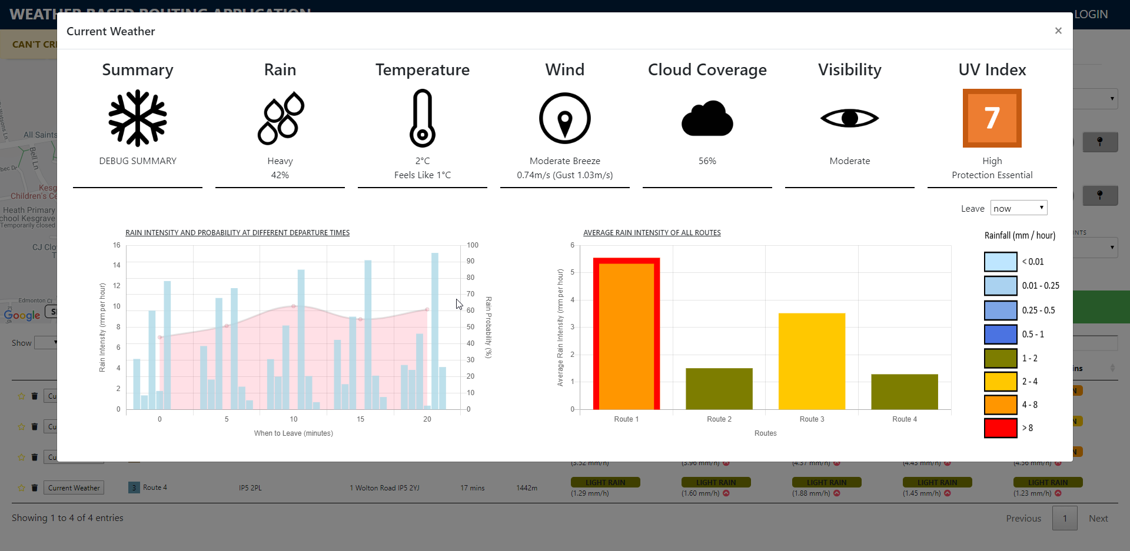

*This is an example of two graphs being used when focusing on weather information for a route. The one on the left describing the rain intensity and probability at the different departure times. The other showing the average rain intensity of each route.*

There are 5 different types of graphs:

* One shows elevation information. This one only has 4 labelled points on the x-axis to reduce clutter. Each point is still selectable, each point is 20m further in the journey.

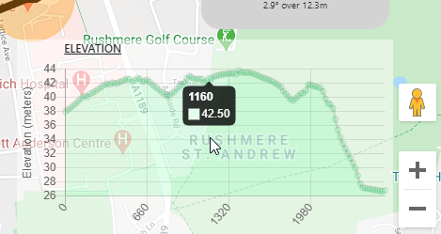

* Average rain per route. This highlights in red the current rain intensity of the route you have selected. The rest of the routes will be displayed on this graph. The colours coordinate to the intensity bracket.

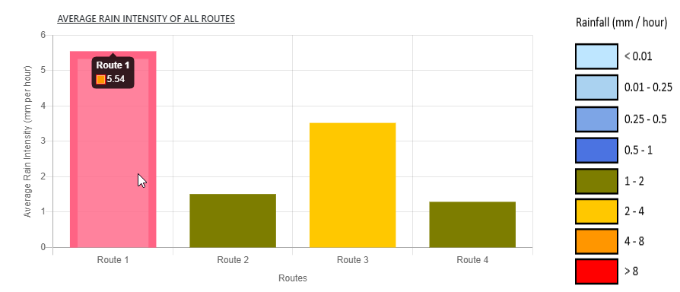

* Rain intensity and average. Both labels are zero based and the probability scale always goes to 100. The rain intensity is displayed by the blue bar chart whilst the probability is shown by the red line graph. Each section is for each departure time showing the users the best time to leave.

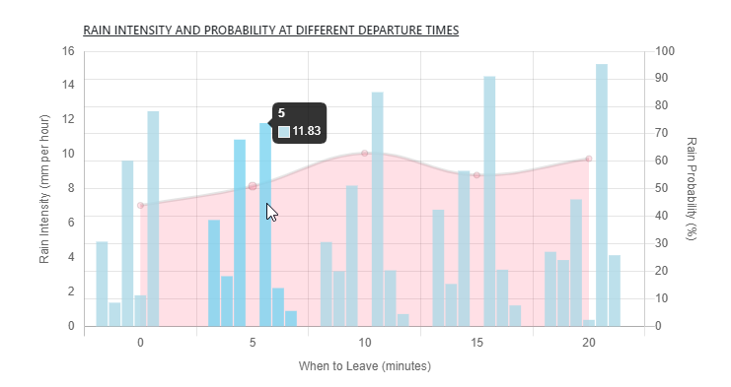

* There are also graphs for just intensity and just probability however I did not choose to make these visible as the rain intensity and average chart covers this.

Hover Functionality

There is a onChartHover function. This event that is emitted is caught on the map component; this adds an arrow to point to the location of the currently highlighted elevation.

Populating Data

The graphs are resettable. It is the same instance of the elevation graph. It just gets redrawn with the new information on every new route/row click.

Generating Data for Elevation Graph

As the elevation graph is every 20 meters and the elevation points are not these distances apart. There is a method that figures out what the elevation would be at the distance on the graph. This works by finding the two surrounding legs and working out, at the percentage between the two legs, what that elevation would be.

Elevation Hovering Usability

The hover state has been set that it will show the nearest x-value. This means that on shorter values it does not need to intersect. This has been assigned a call-back that limits the values to 2 decimal points.

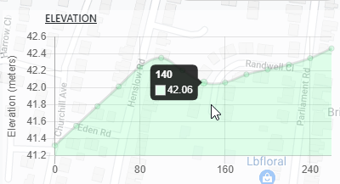

*This shows how the on hover responds to the nearest value. It does not have to match the exact x-axis distance value. This helps the hovering functionality be far less finicky.*

Generating a more Accurate Rain Intensity Average

Elevation is received at each leg. As the elevation graph marks the elevation at each 20 meters, I need to calculate the elevation at these points. This is done by getting the two legs that encase the distance and their corresponding elevations. I then work the percentage the graphed distance is between these values. This allows me to make an accurate elevation result for equidistant graphed distances.

#### Icon Text

This is an incredibly simple component. It displays a title, icon, and text. I create a component so I could easily isolate this code, the beauty of it was you just had to enter an object to it. If an array was entered a row of icon texts were created allowing for easy creation of duplicate code.

These components are used to dynamically show current weather information. Depending on the information provided the text and icons would change, such as the wind direction bearing on the icon.

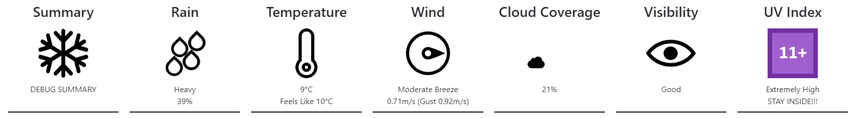

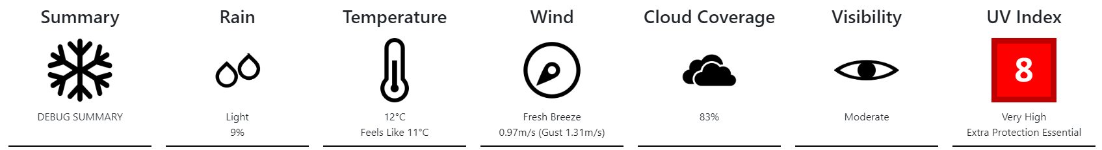

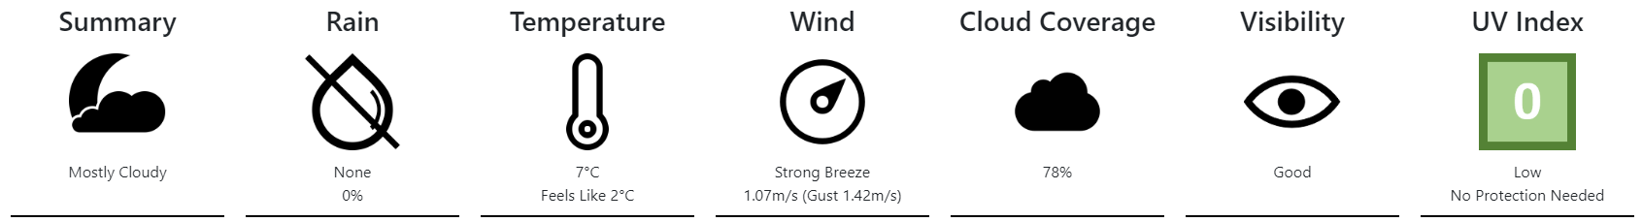

#### Login Modal

This form uses Form Group which is part of angular forms. This allows me to add validators to the fields and control when the login attempt can be submitted.

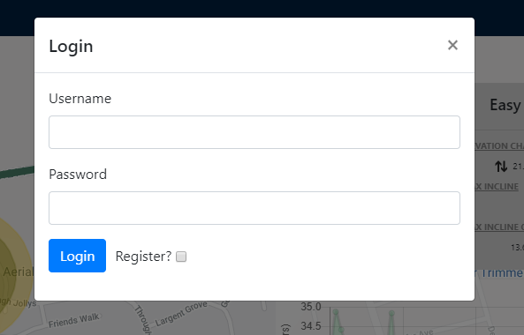

*This is what the login modal looks like when it appears.*

Validation

When these validators are incorrect, after a submit the user will be warned of this. Once these are fixed the validation hint is removed. You can only submit if both the inputs are valid.

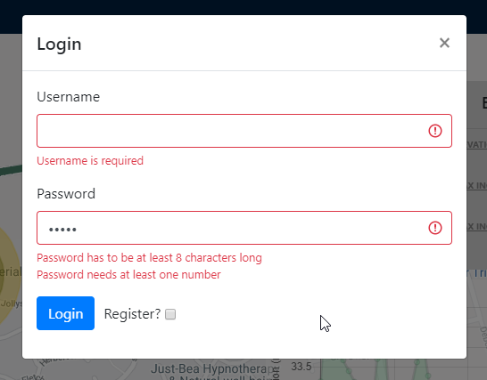

*A login modal showing the alerts provided by ngForm.*

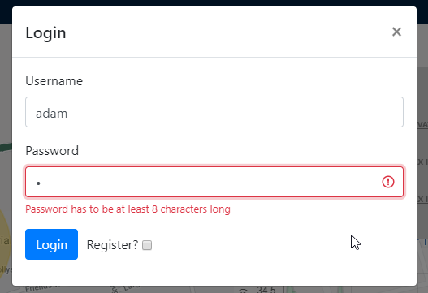  
*This shows how when I add “Adam” into the username field and “1” into the password field. the errors are dynamically removed as the validator is fulfilled. I would still not be able to submit as there is outstanding validation that is not fulfilled.*

There are also errors that are not to do with the values that are stopping submitting, however, they are errors that could be performed in the further steps of validation after clicking submit. An example of this is that credentials are not correct to a user in the system. These are the three errors of this type that can be shown:

1. The user does not exist
2. The credentials are wrong
3. When registering, the username already exists

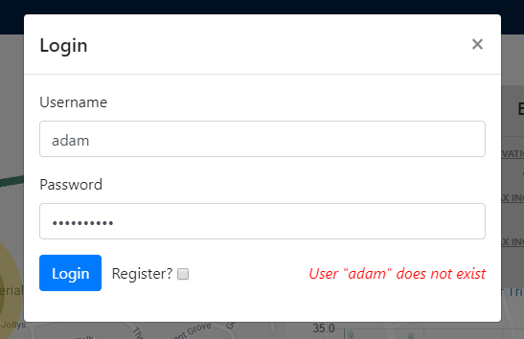

*Here is an error that appears with valid inputs, this is an error that informs the user that a user with username “adam” does not exist.*

Clearing

When the user logs in successfully the login is closed and the fields are cleared. This is to stop someone from logging in again with someone’s valid login details.

#### Map

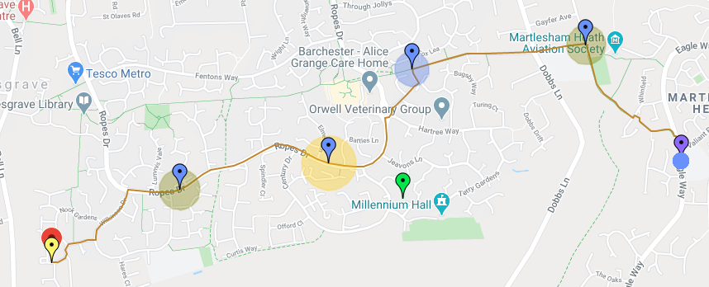

*The map component showing a route.*

Map is the component that holds the google maps GUI. This is where routes are displayed, their corresponding elevation or marker information is also displayed here as well.

Route Additions and Removal

Routes are added once they are created. They are coloured randomly, centred, and bound to the map. Routes can also be removed. When this is the case, all GUI elements attached to it (rain intensity indicators, markers, and elevation underlays) are removed.

Route Highlighting/Unhighlighting

When a route is highlighted the width of the route representation is increased. A route can be unhighlighted which leads to the graphical representation to go back to the default width. If another route was highlighted, there is a procedure in place to unhighlight any other highlighted routes.

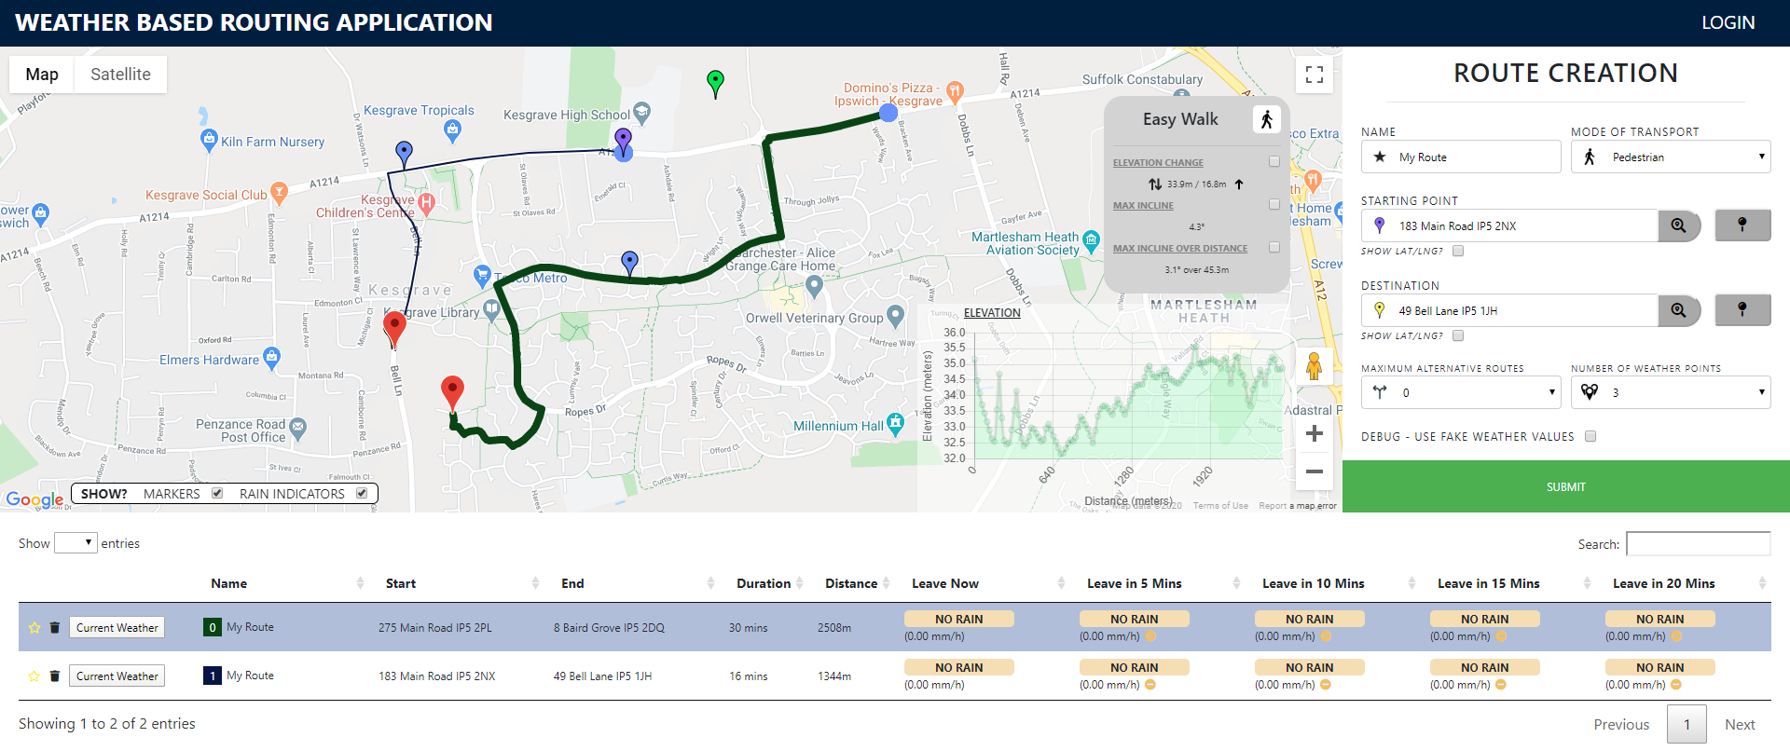

*As you can see the first route is being highlighted in the table and in the map. The polyline is a thicker width to show this graphically.*

Focus

When a route is created or highlighted the route is focused on. What this entails is that the route is centred on the map and the map is bound at a zoom level where the entire route is visible. Centring also occurs when markers are added.

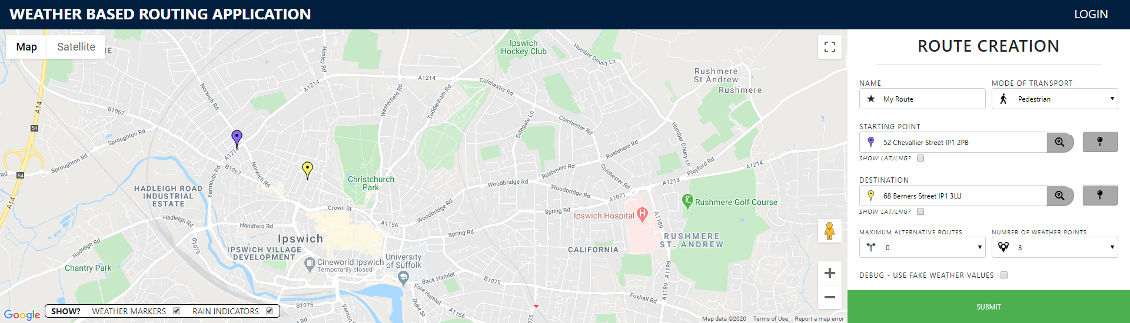

*The starting point and the destination are set…*

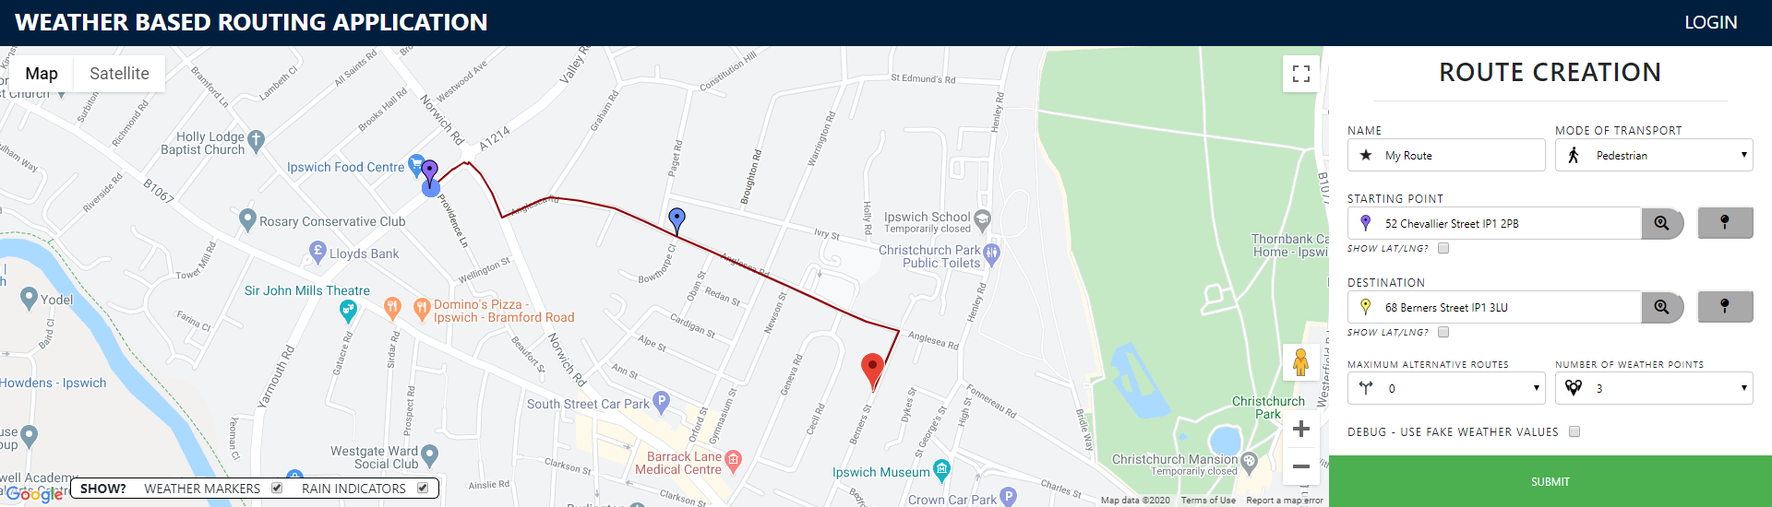

*… Then when the route is submitted the routes is centred and is zoomed in.*

Clicking the Map to set starting point or Destination

When clicking the map nothing happens. Once you click the “pin” button, it is given a red highlight. This indicates that where you next click the map, the starting location or destination marker will be placed. Dragging of the map does not trigger it to still allow the user to navigate the map.

When you click the map, the marker is placed, and the button is no longer highlighted. If you click the map now nothing happens which is the wanted action. This occurs as a result of the map being assigned a click listener, this is explained more in the technical document (<https://cseegit.essex.ac.uk/af17923/weatherroutingfrontend>).

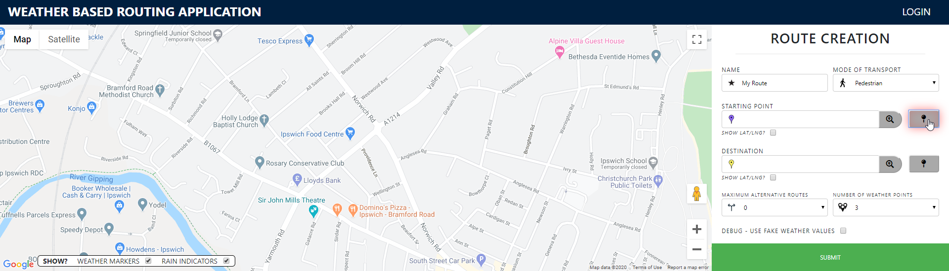

*Before this, clicking the map does nothing. Now I have clicked the pin button for the starting point…*

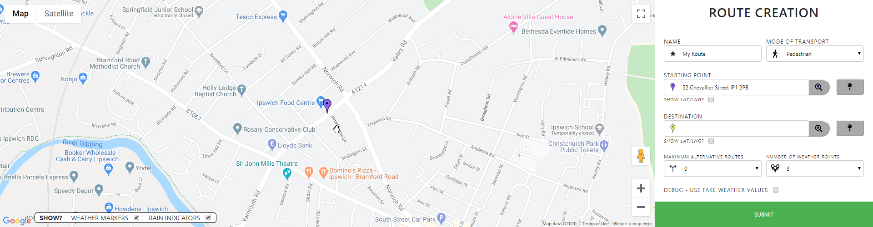

*… I then click on the map, the starting point marker is placed, centred on the map, and the pin button is no longer highlighted.*

User Location

When the user first uses the website, they will be given the popup to allow use of location, if this is ticked then the map will centre on the user’s location which is marked by a green marker. If not the map, when loaded, will display the default location I defined. This location is a zoomed-out showing of the middle of England.

As the location allowing saves over page refreshes. When the page is entered again it will immediately jump the user location. If the location is accepted after tweaking of the page. The map still jumps to the location.

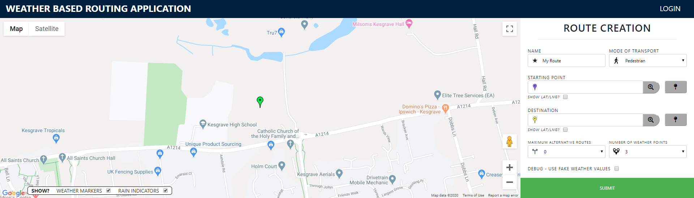

*When I accept my location to be tracked the map centres on my location. Refreshing the page also does this…*

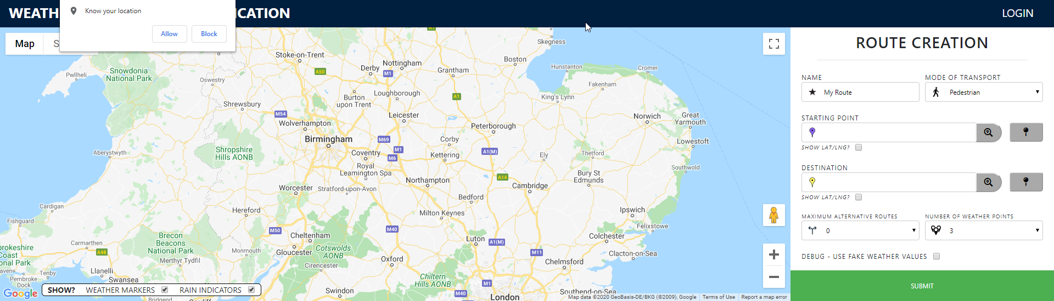

*… Refreshing without location tracing being approved. Get a popup and the map opens on the default location stated above.*

Rain Intensity Indicators

To quickly show the user how the rain intensity changes over the route I added a feature where circles appear over each weather point. The intensity of the rain then changes the size and colour of these circles. The colour matches the universal colouring scheme for rain intensity for consistency.



*This is an example of a route. This quickly tells the user that there will be a spike in rain half way through the journey.*

Togglable GUI Elements

In the bottom left of the map I have added an element that can toggle the visibility of markers and rain intensity indicators. This is a good way to avoid clutter of nearby routes.

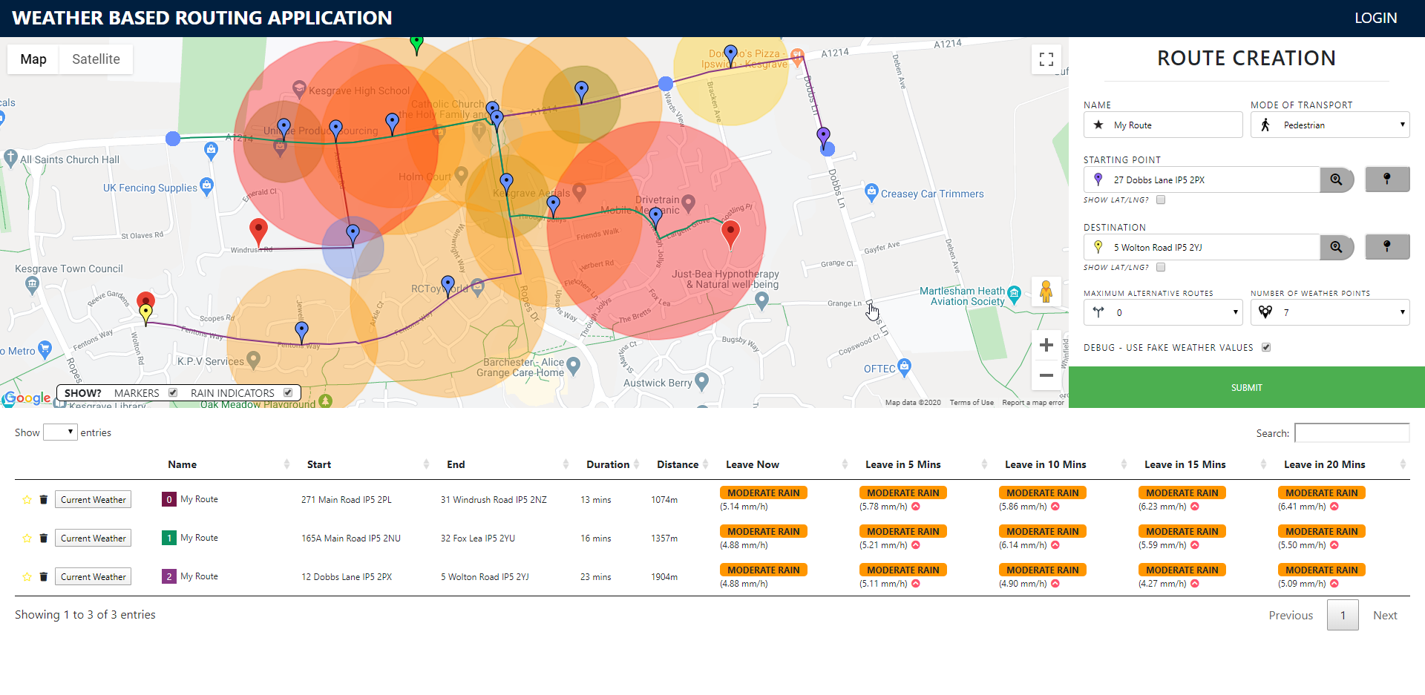

*This is an example of a cluttered map. This has a defualt visiblity where both the rain intensities indicators and markers are visible.*

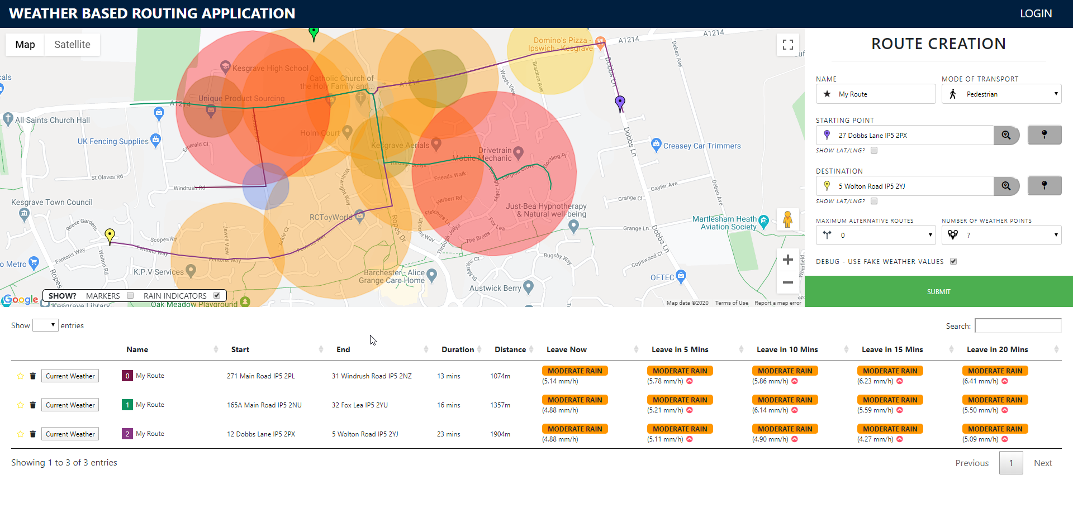

*This is the outcome where markers visibility is togged off.*

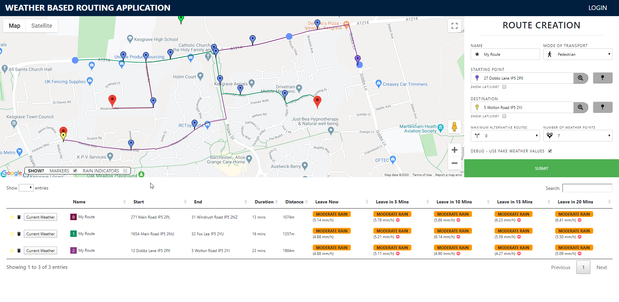

*This is the outcome when the rain indicator is toggled off.*

Elevation

Elevation information is added into the map as underlays and a pointer element. This has, however, been discussed previously when talking about the elevation information component.

#### Weather Modal

This is a model that shows the current weather information. This is a component that is used to give users more details about weather. Where the table provided quick data, this allows for people more interested in the nitty gritty details to fully see how their route will be affected by weather.

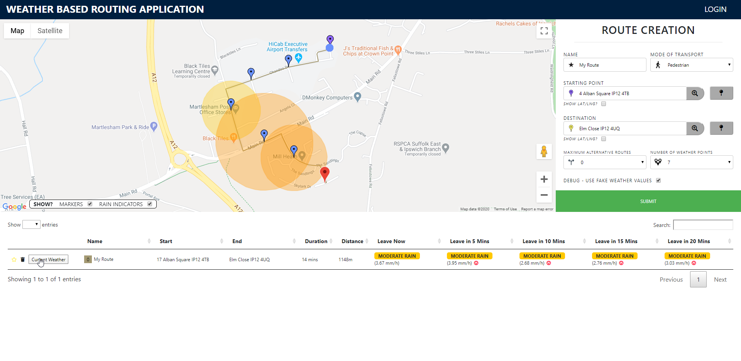

*When the “Current weather” is pressed…*

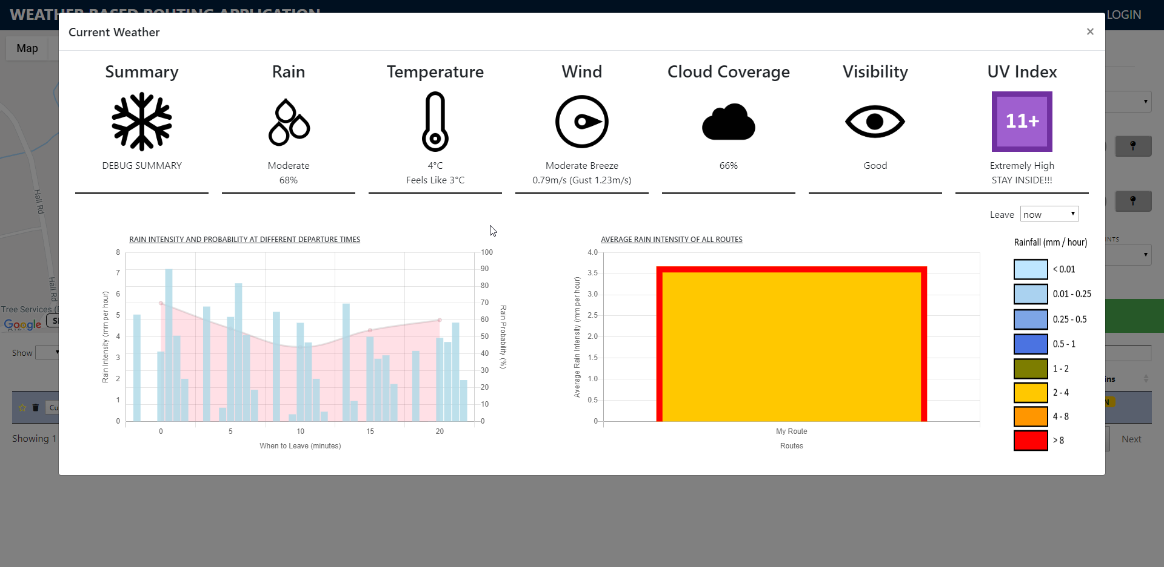

*… this modal appears.*

Current Weather Icon Texts

In the top section of the modal is use the icon text component to create genetic components to show the user different aspects of the current weather. This is explained later in detail when talking about this component.

Graphing

We have the rain intensity and probability graph to the left and the average rain intensity of all routes on the right. On the rain intensity of all routes graph, there is additional functionality on this modal where you can choose the departure time, which in turn gets the average rain intensity at the departure time specified. These graphs have been constructed by the graph component which is described about later.

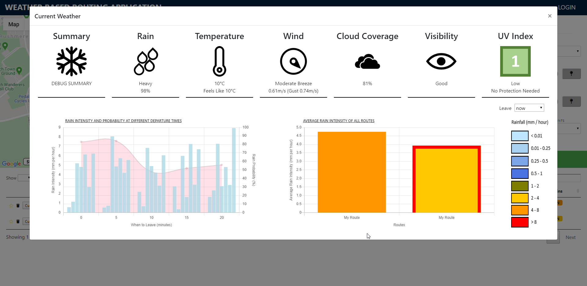

*This is showing the average rain intensity of each route. We can see that if you took the first route you would encounter heavier rain. The second route is the one we are focused on shown by the red outline.*

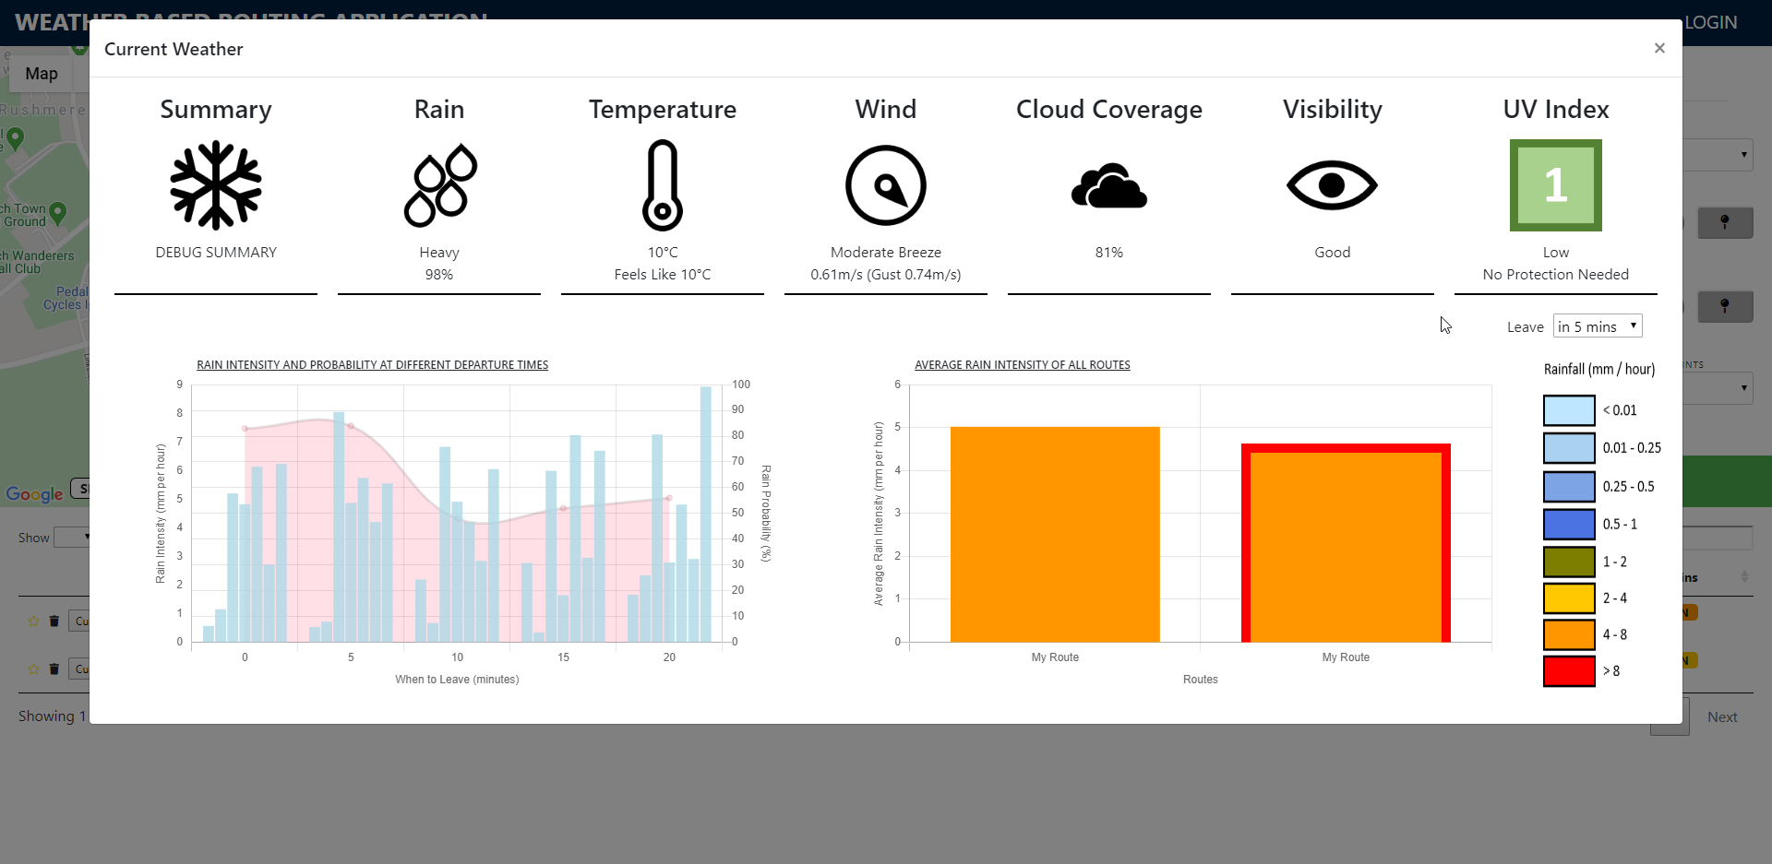

*By changing the departure time to 5 mins later, we can see that the second route will receive heavier rain if the user departs then.*

#### Navbar



This is a simple component that holds the title of the application as well as the controls for the user to login.

Login Functionality

If the user is logged out, a login button will be present in the top right corner, if the button is pressed the login modal is brought up.

Once a successful login occurs, the login button is replaced by a logout button. In addition to this I added a little graphical element to clearly show the username of the person logged in.

Persistent Login State

When you login your credentials are saved to the browser as a cookie. The navbar immediately shows this information by showing that the user is logged in when they enter the website after visiting it before and remaining logged in.

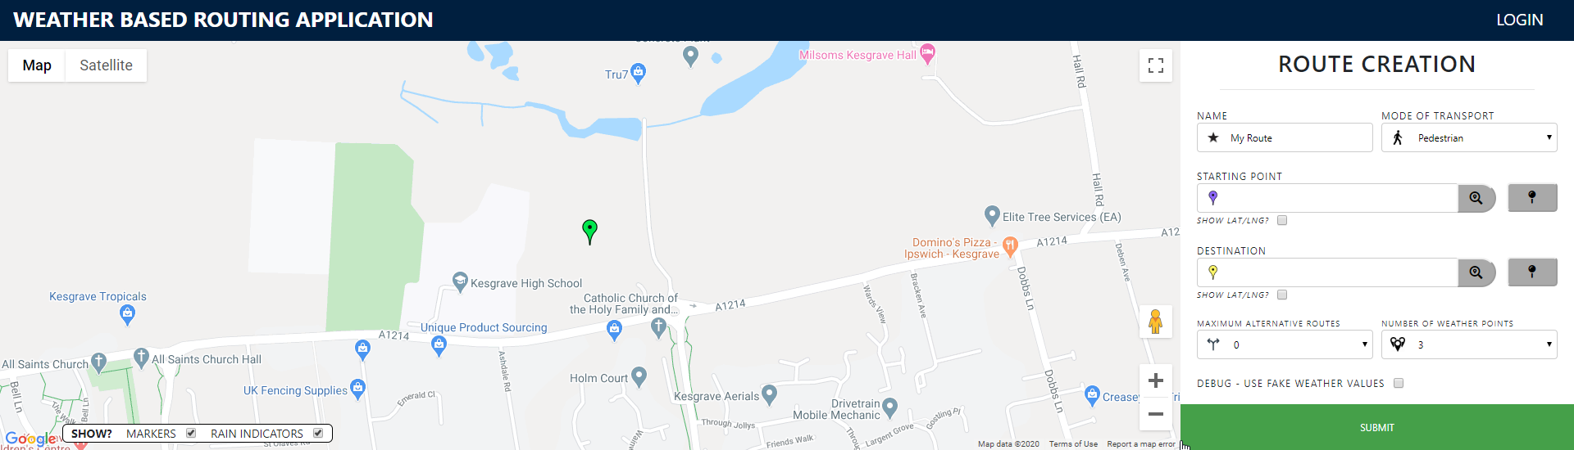

*When login is pressed…*

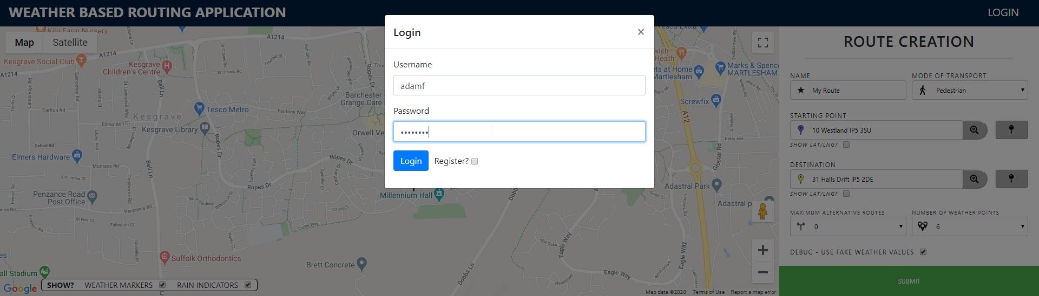

*… and I enter a valid username and password…*



*… the modal disappears, and the login button is replaced with a logout button and a graphical representation of the username with corresponding icon.*

#### Route Creation

Route creation is the component that allows the user to enter details and for these details to then create a route. Information will not only be added however information will be added or updated depending on the action the user makes.

Creation of a route

When a valid route is submitted, the route is created. This information is then sent around the application to update the GUI. This information is used to add a graphical representation to the map component and to add a row to the route collection table.

Input Icons

I added a graphical icon to be added to each input, in response to this I also made the input start further to the right so neither would overlap. The icon can also update dynamically depending on the value selected.

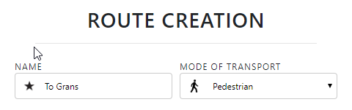

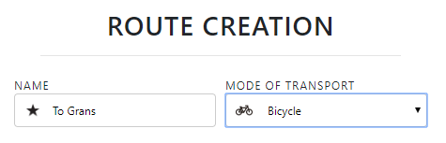  
*When changing mode of transport from “Pedestrian” to “Bicycle”, the icons dynamically change to reflect this new value.*

Text Inputs and Dropdowns

Present in this component is a name text input, this allows the user to enter a name and this name will be added to the route information. There are also 3 dropdowns present, “Mode of transport”, “Maximum Alternative Routes” and “Number of Weather Points”. These dropdowns are given a predetermined range.

Starting and Destination Point Address and Map Assignment

There are multiple actions associated to setting a starting location or destination.

Firstly, you can type an address into the input box, this will add the associated marker to that location on the map. It will only search the name once the search button attached to the input box is pressed. If the address is invalid an error will appear.

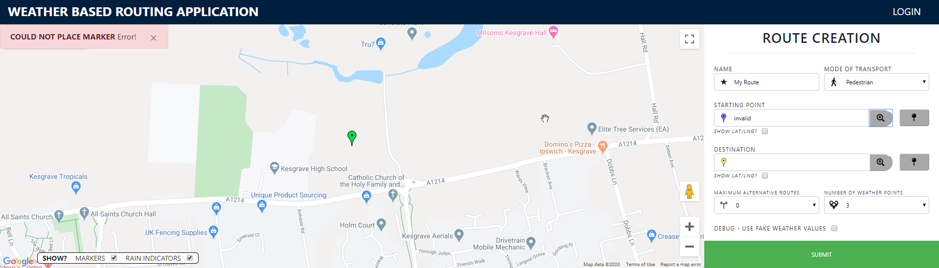

In the background it is calling the “Google Geocoding API” which will return back the latitude and longitude values which are then used to mark the marker on the map.

The second way is to click the map after making it selectable. If you were to click on the map as soon as the website starts nothing will be achieved. Once you click the pin button it will glow red, indicating to the user that the map is clickable. Clicking the map then places a marker and also unhighlighting the pin button. The map is back to the state where you cannot place a marker by clicking.

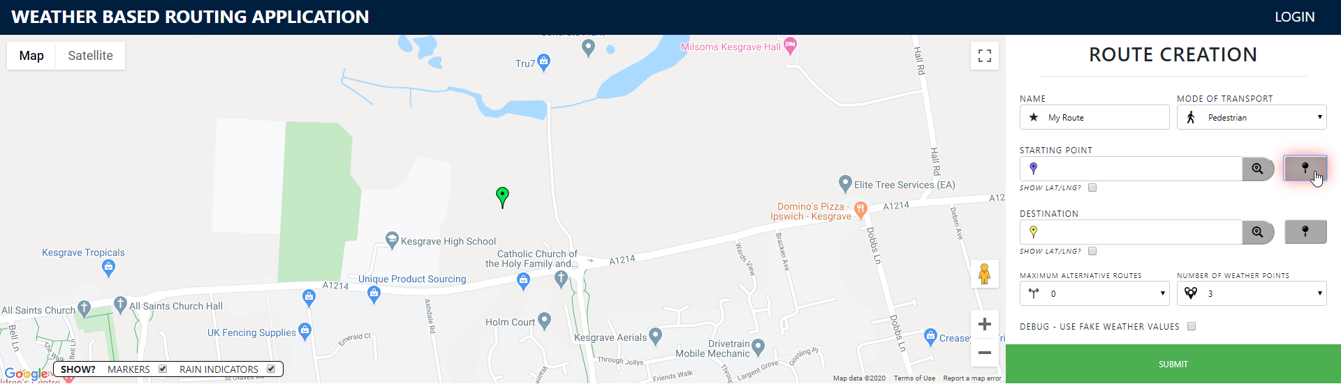

*I click the pin button highlighting it…*

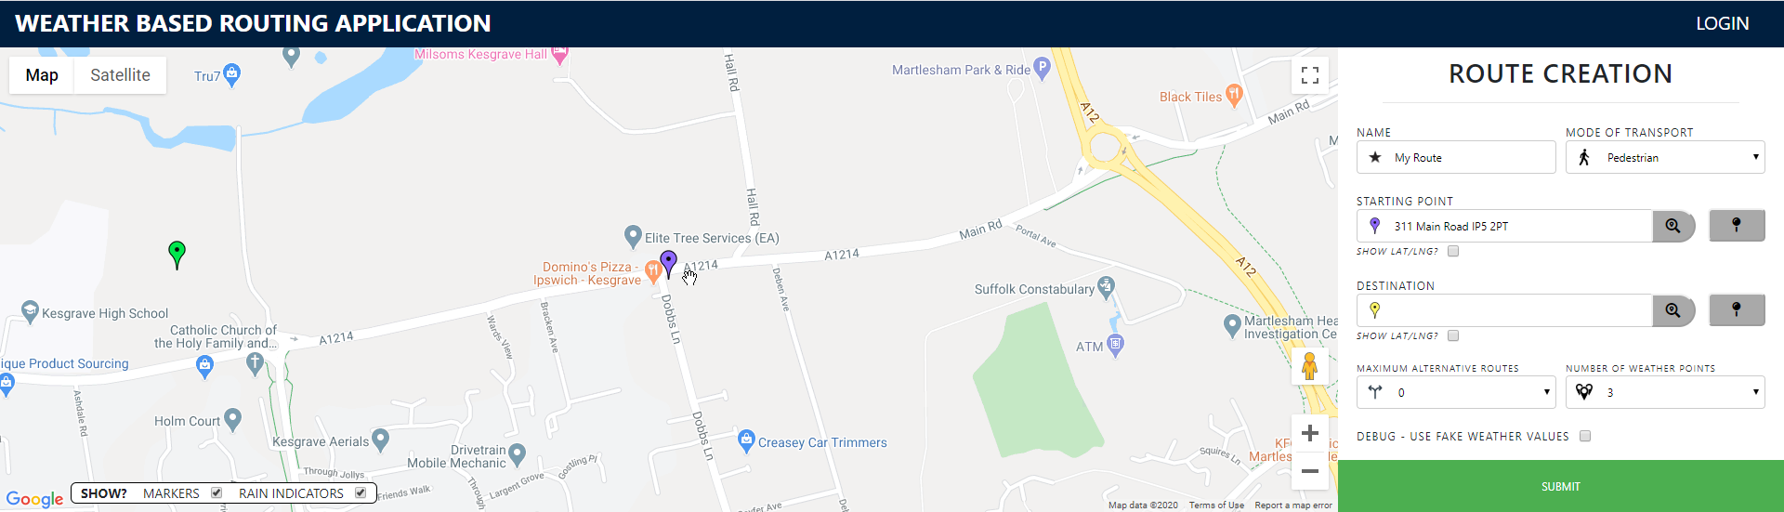

*… then I click the map to place the start marker, also unhighlighting the pin button.*

The third way is defined by stating the latitude and longitude values.

Starting and Destination Point Latitude/Longitude Assignment

I have added functionality where a user can define latitude and longitude values and set a marker this way.

To view the coordinates you press the checkbox, doing so swaps out the name input and actions with the latitude and longitude input. You can then update the latitude and longitude values here. You can then subsequently press the submit button to then place a marker at the lat/lng values defined.

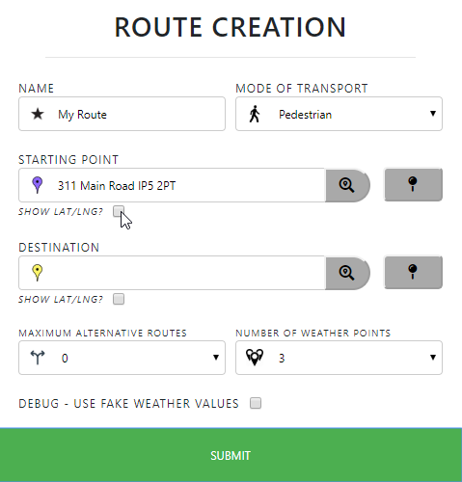

*I click on the starting point “show lat/lng?” checkbox…*

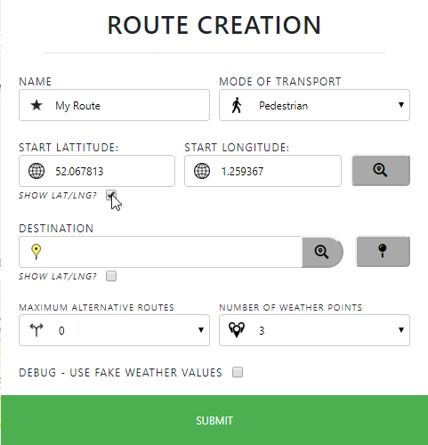

*... this checkbox is now ticked. The name input and buttons are replaced with the input for latitude and longitude and the corresponding search button.*

Updating related Data Dynamically

If the starting location or destination is updated. The other related values are updated. There are three linked data:

1. Name
2. Lat/Lng values
3. Marker placement

If either locations are updated by updating one of these values, the rest of these will match the new value.

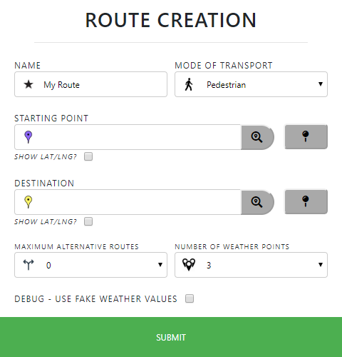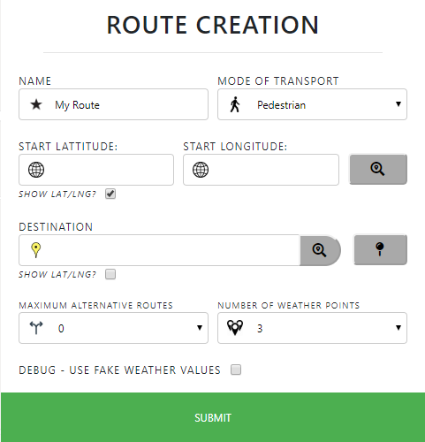

*If I start with an empty route creation form. If I update the marker by clicking on the map…*

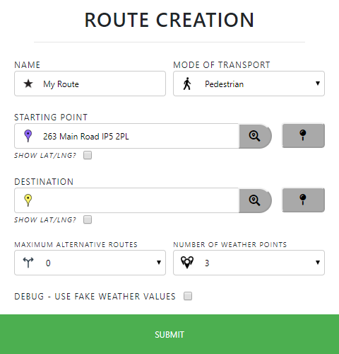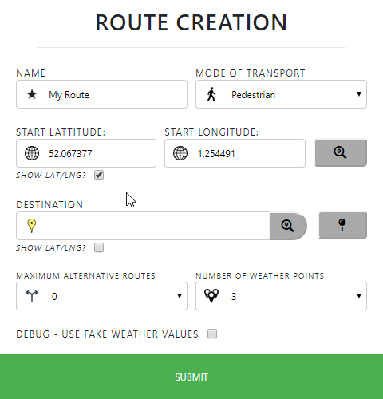

*Then the marker is updated. Not only this but the name and lat/lng values have also been updated.*

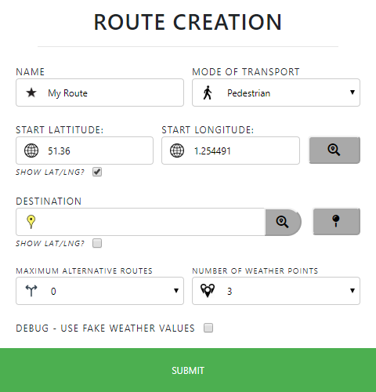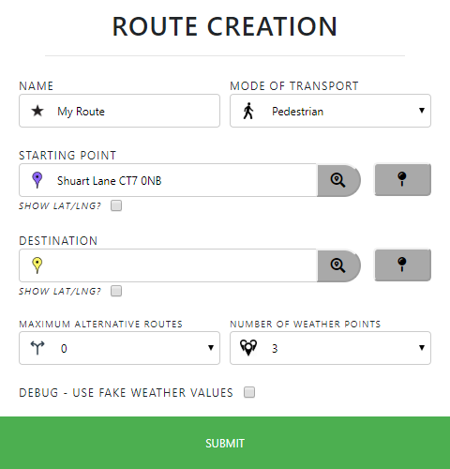

*Finally, if I update the latitude value and search for it. The marker and location name are updated. What this shows is that no matter how the information is changed. All linking information is also changed to keep consistency.*

Route Submission

The route will only submit if it is valid, if the submission is invalid then there is no visual disparity of the route submission component, there are however warnings to tell the user what is invalid with the submission.

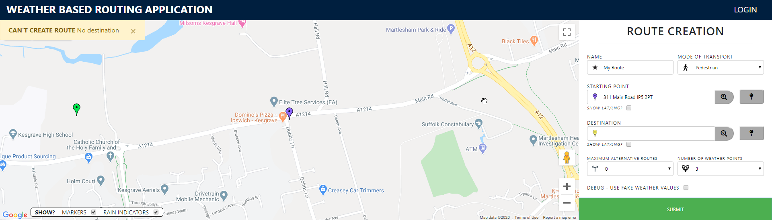

When a successful route is submitted the submit bar will show a loading spinner, during this the user cannot submit another route, this is great to avoid accidental multiple clicking generating identical routes.

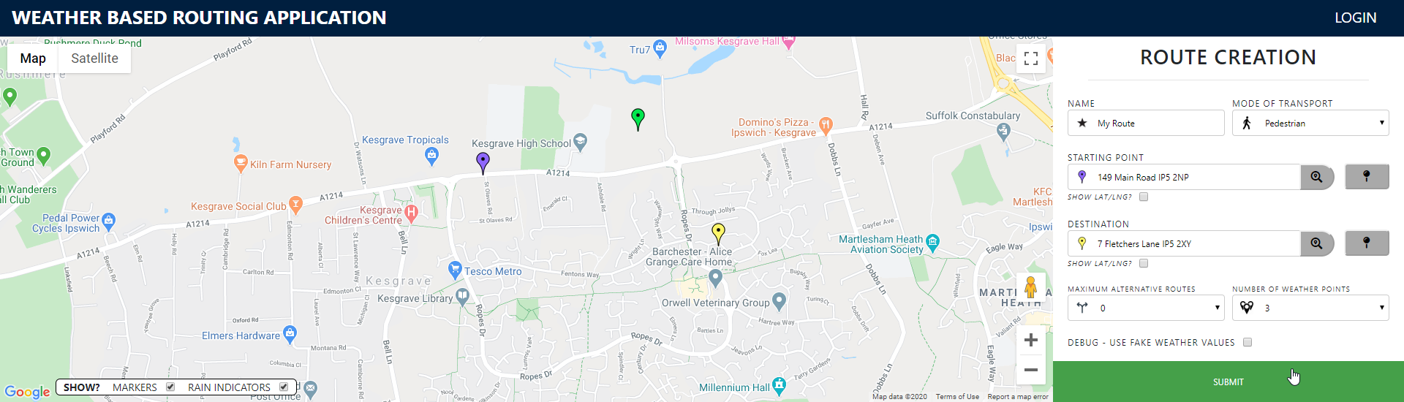

*When clicking the submit button when the form has valid arguments…*

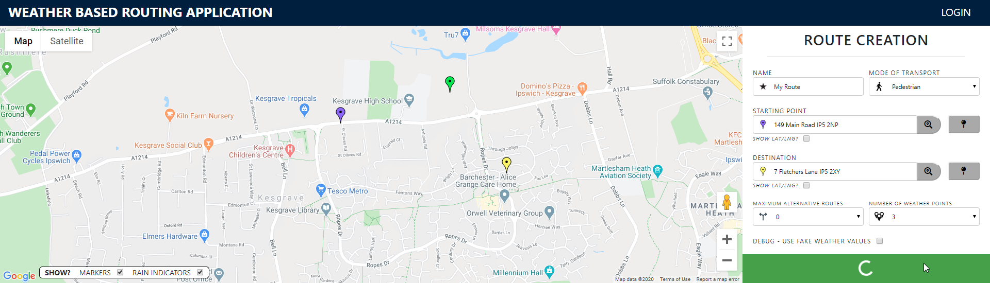

*… The submit button turns into a loading spinner. Returning to the submit button once the route has been added to the map and table. The loading spinner cannot be clicked on.*

Fake Weather Data Selection

This is where we have a checkbox to toggle if real or fake weather data should be used.

#### Route Data Table

This table is a library called datatables.net. I chose this framework as it has really good documentation and I had been recommended it by someone who has used it before for a project. The table is designed to hold each route and display to the user information to quickly provide them information on their route. If they wish to know more information, then they can go further.

Table Functionality

This table comes with several functionality. One is searching which search defined route cell data to match. Another is pagination, I have set the number of routes to 4 before using a new page, the number of entries is changeable if the user requires so.

ordering functionality, searching and pagination. This is useful if people want to order by route name, distance, duration etc (E.g. someone can toggle by duration to choose which route to go for a walk on).

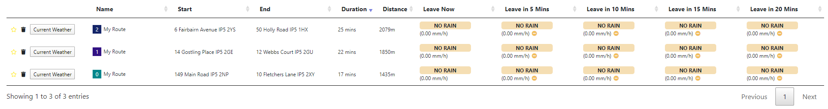

Route Highlighting

When a route is clicked on the row is highlighted. When another route is clicked on this is highlighted, unhighlighting the previous row if necessary. If a focused route is clicked on then the route is unhighlighted.

Route Numbering and Colouring

A route number has been added to better allow users to see the creation order or routes. This colour matches the route colour graphical representation on the map. A contrasting colour is then calculated and used to make the number most visible inside the coloured square.

Departure Time Route Quick Rating

To quickly provide the user with information relating to the route, I devised a coloured rain rating. This follows the same colour scheme regarding rain intensity to keep consistency. I added descriptors to better define to the user how the route will be rain wise.

This describes the rain for each route, for each departure time. This can be used by the user to determine the best route to take whilst also deciding the best time to leave. In the image below I can see that the fourth route gets worse if I were to leave 10 minutes or later, prompting me to leave as soon as possible.

Rating Comparisons

There are also icons that shows if the rain is worse better, or the same at each departure time compared to leaving now. This again gives another way for the user to quickly decide which departure time to take.

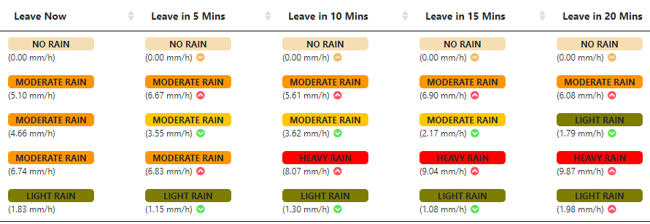

*The third route shows all green down arrows indicating to the user that the rain would be better if he left at any time compared to leaving now. The fourth row shows that leaving now would be the best action. The last route however shows to the user that the route gets better if they leave before 15 minutes, after this the route actually gets heavier rain.*

Technical (jQuery, adding html in typescript)

I had to perform jQuery and pure JavaScript code to read and manipulate the table, such as finding the row number of the row that is highlighted. This is explained more in the technical documentation (<https://cseegit.essex.ac.uk/af17923/weatherroutingfrontend>).

Route Favouriting

Routes can be favourited by clicking the star icon on the route. By doing this when a user is logged in, the route is favourited and saved to the user. If the user were to login again this route would appear. The star is filled when the route is favourited and an outline when it is not.

A route cannot be favourited when the user is not logged in. This shows a warning to the user to make them aware of this fact.

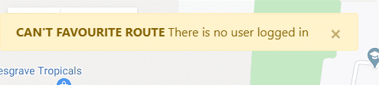

Route Deletion

Route deletion occurs when the trash icon is pressed. This removes the route from the table, removing the highlighting status if it was highlighted. If the route was also favourited then this route is also removed from the user’s account.

Weather Information

When this button is pressed it brings up the modal on weather information. This allows users to find more in-depth weather information on the route of their choice.

### Models

These are not all the models, most of them are purely for ordered data collection. There are a few however that are worth mentioning as they perform other actions. These actions are performed in the model for code isolation and more organised code. There are many models, the ones below are one that perform extra actions and are worth mentioning.

#### Elevation Info

This encapsulates all of the information relating to elevation. This model is then assigned to the Route Information Model to assign this data and make it accessible to the route object. This model works by populating the results on initialise. It starts by getting elevation information and once this happens it then performs extra actions to get other information:

Elevation Change

There is one value which is the total elevation change, this is a simple comparison of the elevation value at each leg along the route. The other value is the total positive incline value, this only returns the elevation gained of an upslope. This method uses simple mathematics including SOHCAHTOA to calculate the angle, it also uses a simple radian to degree conversion to get the universally more accepted angle output.

Slant Angle

There are two values saved to this object relating to slant angle. One states the largest angle of positive incline between two legs, whilst the other states the largest slant of one continuous positive incline straight.

Incline or Decline

This method saves to this object an array of Boolean values, True for a positive incline between the two most recent legs and false for a negative incline. this is then used by the map component to display red and green underlays to show to the user this graphically more clearly.

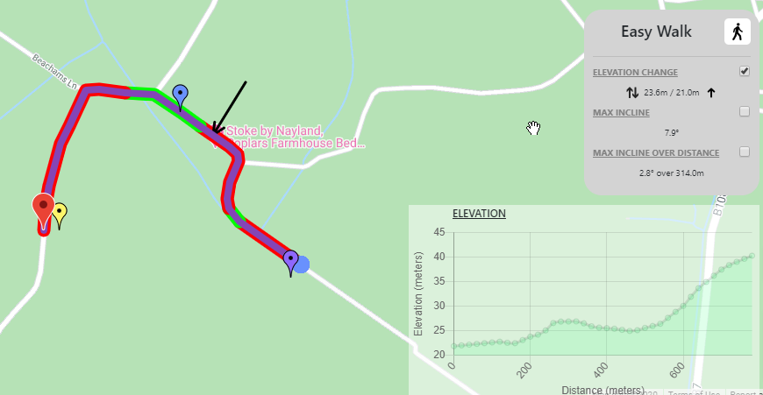

#### MyChartOptions

Chart options are used to define the structure of the graph. These are applied to the DOM canvas to define the graph.

#### RouteInformation

Route Information is the model I have used to objectify a route. This is used to pass around the program and is used to save the data and state of a route. To avoid adding more arguments into the constructor I decided to calculate values in the model, these values could be calculated by data saved in the model, It was a great idea to hold these methods in the model as it consolidated code, isolated code and reduced the number of inputs. These methods are as followed.

Cumulative Distance

This calculates the distance between all the legs and saves this. This distance between points is retrieved by calling the routing service and the cumulative distance information is used when getting the elevation information to get information correct to the relative distance along the route with comparisons against the rigid leg distances to work out the exact distance the lat lng value would be along the route.

Polygon Bounding

I simply just use a google method to create a boundary that will fit the polyline I enter. This is used to make sure that when a new route is added to the map, or a current route is highlighted, that the route is centred zoomed in an amount where the entire route is visible.

Contrasting Colour

A contrasting colour is assigned to this object, this will be used on the route identifier on the route coloured square on the table. As the colour is random, I need a contrasting colour so no matter the colour it will be visible. This contrast compares to this colour and depending on the brightness, will define this colour as either black or white.

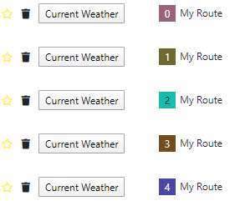

Starting Point and Destination Name

This communicates with the backend to get the location name and assigns it to the route object.

### Services

Services are injected into components to abstract away data manipulation; it also isolates the code, so it is easier to manage. Service injection makes the program more loosely coupled and allows for easier testing.

There are four services that I have created, each which are designed to consolidate areas of information: Authentication Service Alert Service Routing Service Weather Service. Information relating to what each service did and the technical achievements attached are present in the technical documentation (<https://cseegit.essex.ac.uk/af17923/weatherroutingfrontend>).

### Assets

I have collected or tweaked 46 different assets just for current weather. These icons are chosen after the current data is compared against ranges I have defined.

* 8 different bearings for the wind direction
* 4 different levels of cloud coverage
* 5 different levels of rain intensity
* 10 different summaries
* 3 different temperature ranges
* 12 UV index identifiers
* 4 levels of visibility

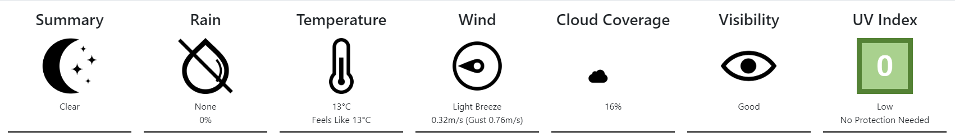

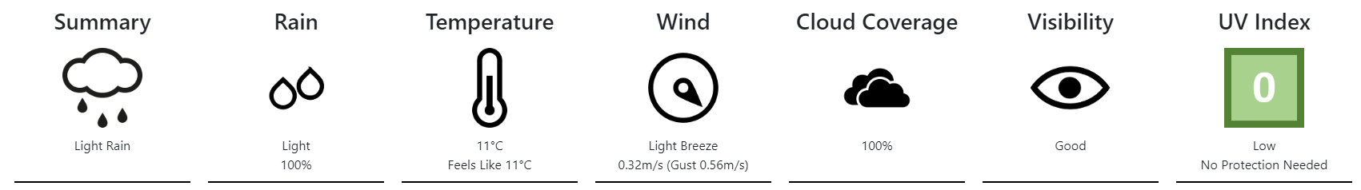

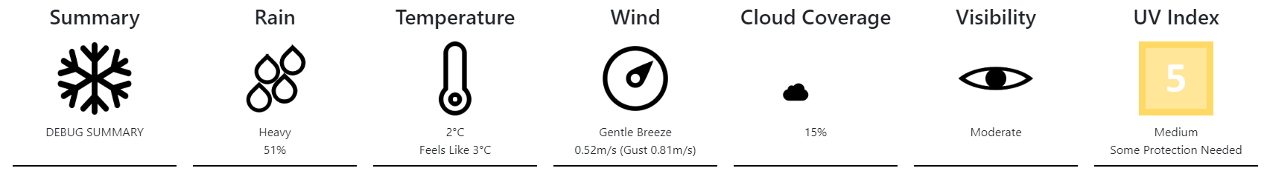

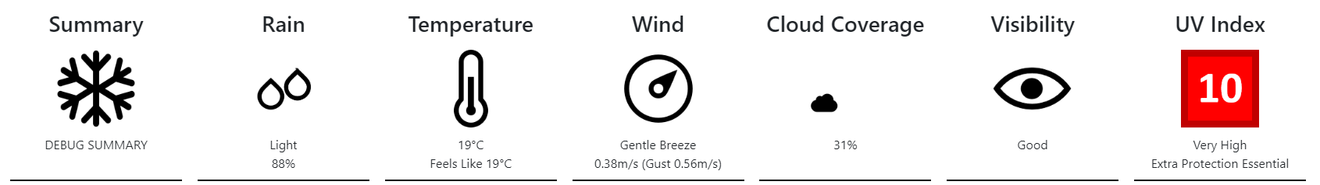

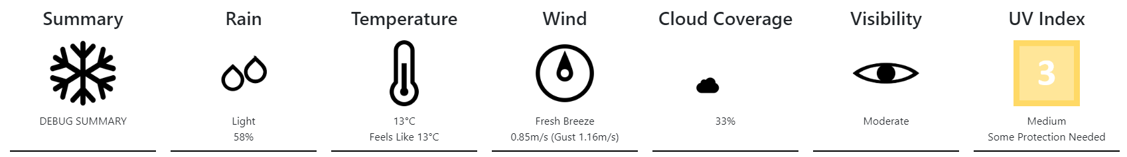

There are 11 other icons for the other parts of the program. These do not include the different coloured google markers that are taken from google website.

## Backend

The backend is a RESTful API .NET Core Project. I use this as the middleman between the frontend, which is user facing, and the 3 data collecting APIs or the projects database.

Information relating to the use of swagger, the four controllers, entity framework, inheritance and the holding of keys can be found on the technical document present on GitLab (<https://cseegit.essex.ac.uk/af17923/weatherroutingwebapi>).

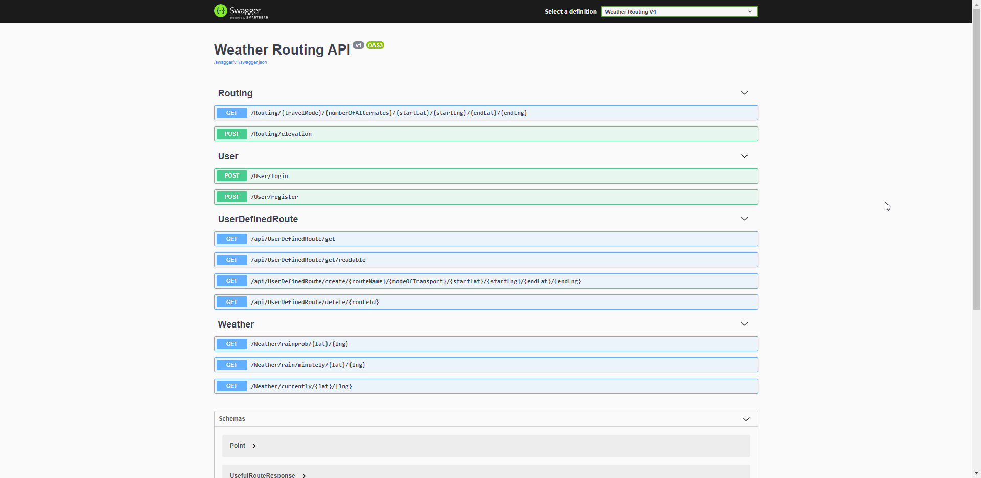

*Swagger GUI that allows for quick calling and readability of RESTful API.*

## Database

The purpose of the database is to hold credential information about a user. It is also used to save favourite route information of a user.

Use of “SQL Change Automation” for version control and information relating to password hashing and salt, database design, stored procedures, Scalar-valued Functions etc, are available on the GitLab database project. (<https://cseegit.essex.ac.uk/af17923/weatherroutingdatabase>)

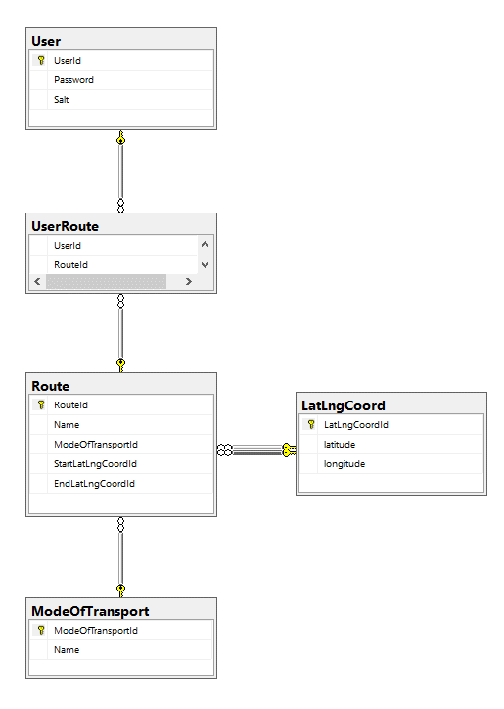

*Database Design*

## Why I Chose the Three API Providers

Mapping API

For the mapping I decided to go with the Google Maps JavaScript API. I chose this as google reputable company, the pricing was also very good, this was because I was given a monthly refreshing amount that I would never reach with me just developing it. I also choose this API as there was very good documentation. The map segment is a large and integral part of the application, it was also the first part of the program I programmed. Because of this I chose a well-documented google API to hit the ground running. From Google I have been given a £244 trial that expires in July. I have actually spent none of this leaning to the fact that I am not reaching notable uses on Google levels.

I use the Elevation API to get information relating to elevation and I use the Geolocation API to get the functionality of name to lat/lng values and vice versa.

Routing API

For the routing I decided to not go with the Routing API provided by google. This is also well documented however I decided to go with the TomTom API. Again, TomTom is a reputable company that provides information to many satnav systems. TomTom also has good documentation and a good selection of parameters to query the data I want to receive. I chose to not go with the easier option of Google as I just wanted a challenge, I also did not want to become two dependants on google. As google money is shared on all the APIs, I wanted to use different companies to expand the amount of calls I could make before paying.

Weather API

Finding the weather providing API took the largest time and research. I initially spent a lot of time with the API provided by the MET office called the “Met Office Weather DataHub”. There were a few reasons why I was unhappy with this. Although the MET Office is a well-known and reputable company, it was obvious to see that there was not much effort put into the product. There was poor documentation, the documentation was ambiguous, so I asked a question, I had to wait a while before getting a reply which actually was helpful in clearing things up. This API only provided hourly weather data with usually quite inaccurate results. For example, the weather reading would be from the nearest weather collector which was often miles from the location I chose. As you can imagine, this information is useless for small distance routes that will take less than an hour.

After more research I found a data provider called Dark Sky which has now just been acquired by Apple. Again, this is a reputable company however this time there was a lot more documentation and documentation of better quality. This API provider removed all problems from the previous API. The accuracy of the data was specific to the latitude longitude values, changing the accuracy from miles to meters. There is also a very important feature that provides minutely rain data, this is very important for my application as minute-by-minute data is something very important to a quick walk or cycle ride. Hourly information would have given me data too broad.

The only downside is that there is a big increase in cost. I am capped to 1000 requests a day. That is why I have programmed my code only to call the API on valid routes, stop spamming of routes and provided a fake data alternative so even if I run out of requests I can still show this functionality.

## Package Management

The Angular application uses npm (Node Package Manager) and the .Net Core backend uses npm (NuGet Package Manager).

I chose “Node Package Manager” for the frontend application as this is the package manager that comes with Node.js. As you use Node.js to set a development environment for an Angular project this means that I also have to use “Node Package Manager”. This is free and integrates with Angular with no extra work on my side. I have also used it before.

I chose “NuGet Package Manager” for the backend application as this is a package manager provided by Microsoft. This means that there is already default implemented support with Visual Studio and the .Net Core application. Again, it works great and there is no extra work that is needed to be done on my side. I have also worked with this before allowing for easier usage.

## Clean Coding

Clean code is a very stressed skill promoted by the company. It is in everyone’s best interest if the code you write is clean, this avoids code smells from appearing down the road. I am very proud of the cleanliness of my code. A massive part of clean coding is the correct naming of methods, writing self-documenting and self-describing code is a great way to program. This is so if someone else was working on the program they would be able to understand it without me having to explain. My clean code was written also in a way that was easy to follow so when I came back from the coursework after a hiatus, I will still able to understand the code I have written, this is vital in my opinion for software development.

Another part is the writing of code to consist of small well-defined methods. This method is very prominent in clean coding and describes that a method should only have one responsibility. Each action should be given its own method. Leading to many methods, all being named correctly. If this is performed you avoid having a massive class or method where everything is done, you instead will have incredibly legible code that is well distributed. I have been quite successful in planning to write my code this way.

## Responsive Design

Responsive design has been something that I have kept an eye on however due to the time constraints I have not made it a priority. This website will currently not work on mobile devices, it has not been designed to work on these screen sizes. Due to using float and percentages I can support larger resolutions. I have a 1920x1800 monitor, zooming out to mock a larger resolution works fine.

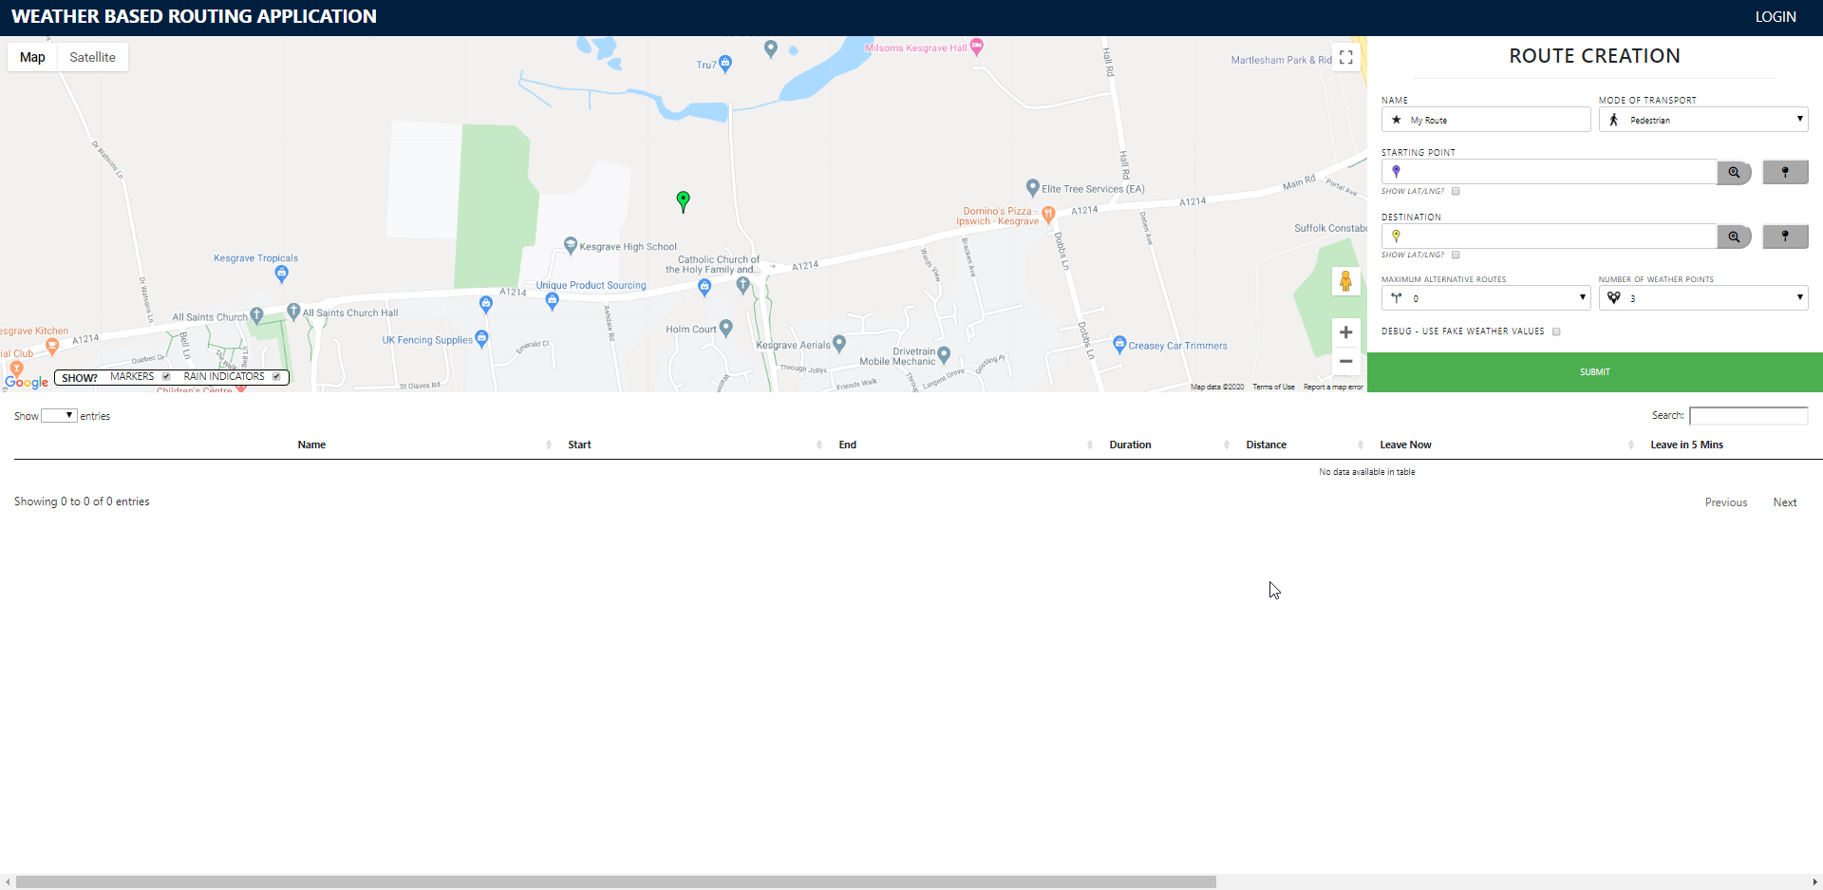

*This is zoomed out to 75% to mock a higher resolution. Every component styles dynamically.*

## Problems I Overcame

There were many problems that I faced in this project. A large complexity comes from having to know all the different languages to construct the three layers. Switching between languages was enjoyable and I know it made me a better developer.

There was some advanced level logic such as the subscribe/observer pattern which I learnt a lot about whilst writing this application. Advanced code practices were also difficult to implement. I have struggled with awaits and asynchronous code. This was implemented in the program however it took me a long time to figure this out.

I had problems accessing the datatables.net, this is a great plugin however required me to use jQuery which I was not planning to do. This is because I could not use typescript. I had to write jQuery functions to know which row was clicked on for example.

The amount of code I had to write in the timespan was a challenge. Anyone can write code, but it takes skill to write it cleanly. This coursework really nailed the fact that clean code is worth pursuing as it does help development immensely.

# Project Management

As an apprentice I have to do a 40-hour work week alongside my studies. This proved very difficult to finish work and to then work on my dissertation.

To mitigate the amount of work I had to do outside of work hours I agreed with the business to take one day off a week to study. This helped me somewhat plan what times I would be studying. However, with other coursework and the technically challenge of work meant that this time would usually be used to work on the most recent coursework or perusing lectures I was highly late on.

As an apprentice time management is something I have come to learn and appreciate the impact of getting it right, or more poignantly, when getting it wrong. It did not help the times where the websites holding my code or Moodle itself would be down.

## Agile

I can say that I used the agile approach. This is because this is what I do at the office already and this methodology is a much better fit for this situation compared to the waterfall method. The supervisor giving weekly meeting helped simulate the strong customer developer connection that is prevalent in agile design. The waterfall method requires that all design be done up front and finished before you start development. This is not sustainable for software of this scale or situation. The ability to change requirements on the fly also helps me create the best product possible and Agile not only allows this but outwardly promotes this.

### Jira

Jira is the application that Derivco uses for story management so I can gladly say that I am aware of what Jira adds to the process of story management, prioritisation, categorising etc.

The benefit of using a Kanban board is that it helps developers stay on track and not go off on a tangent. Well defined stories will explain exactly what is required in the story. The process of creating stories and developing a background shows the progress of a system. This also allows for easy insertion and prioritisation of stories. In business this would be the product owner’s job to instruct the team of new stories and to find a middle ground between the development team and the customer in regard to prioritisation of stores.

Fitness is the act of finding out the pace of development. When stories are given correct story points this can be used to estimate the delivery time of certain milestones.

Jira is best taken advantage of when there are multiple people. It is vital in a software company.

Epics can be used for categorisation and the breakdown of very high-level features e.g. weather information graphing or user login. The example below is called “table” as it encompasses every task relating to the table component in the application. This is a good way to keep track of the process of high-level processes and to plan the long-term development.

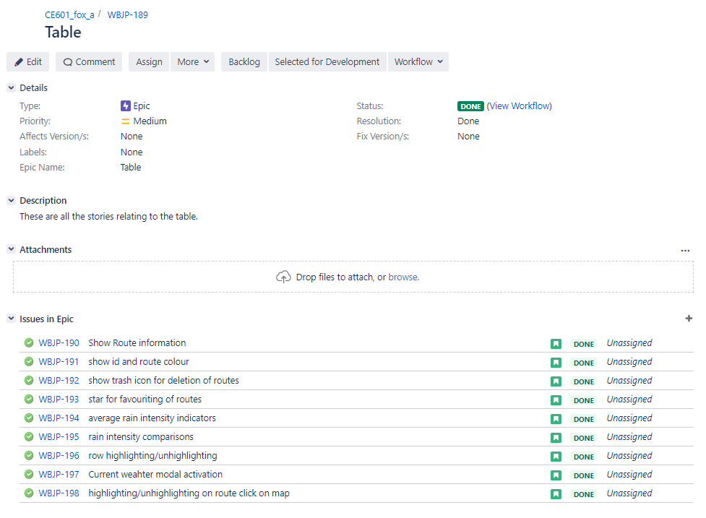

*This is showing the epic “Table”. Below are all the stories relating to this epic. This is great for improving organisation and seeing how far along this feature is.*

The act of sub tasking is important. By breaking down subtasks you are creating smaller features. This allows for smaller features to be divided by the team. Smaller well-defined features are usually more accurately estimated due to the smaller number of unknowns and smaller scope. Smaller features also help promote developers to stay on track and not deviate from the task. When it is a larger task it is easy to go off on a tangent and write code that is not specifically described. This can be cause by ambiguity which is simpler to fix and spot in smaller stories.

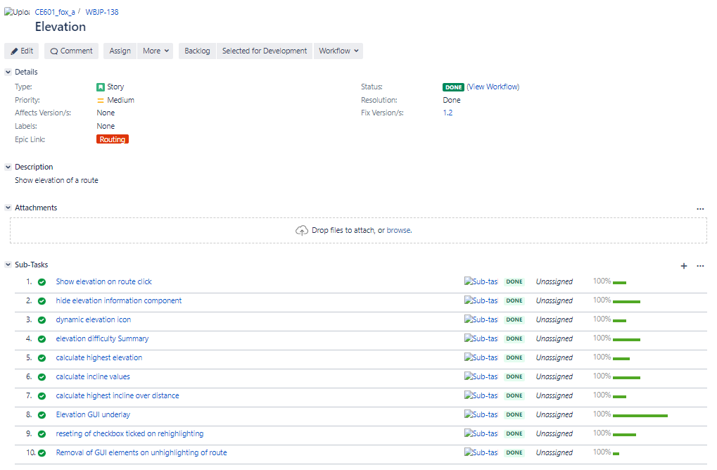

*This shows show substories are created to make smaller tasks that can be defined and tracked further.*

### Maintaining Momentum and Adapting to Change

As an apprentice doing a dissertation alongside coursework, revision and a full work week was incredibly stressful. As coursework and work commitments would rise and fall as time progressed, I had to shift time towards and away from working on my coursework. I am extremely proud of myself of the will to work on this project and to be proud of the outcome despite of the other commitments and the amount of free time I had to sacrifice. Time management as an apprentice is vital.

There would be times where I could not feasibly work, watch the lecture, perform the labs, work on coursework. When this happened, I would either have to postpone lectures or negotiate with work on hours I could be spending studying. I would say that I adapted to change very well and in a professional manner. Not only do I have to work out a timetable of everything I am studying, I have to negotiate with work, this is another layer that most people don’t have to go through, and I hope that the mark of this coursework reflects this fact.

## Version Control

Version control is something at the very start of my apprenticeship that I thought was an unnecessary step, something that just got in the way and was no benefit to anyone. I could not have been more wrong. Version Control is vital, and I would say that without this software development would be promotionally more difficult.

For this project I was given a GitLab account to use. Here I created 3 projects to divide the frontend, backend, and database.

I briefly used branching but as I was the only person working on this application, I went to pushing straight to master, this is an act punishable by death if this was done at Derivco.

A great benefit of version control is experimentation. Once you commit and push you code it is safe. After this point you can work on the next problem, if you are not happy with the code you have written you can then start over from the nearest commit, I find this extremely useful when debugging a problem or experimenting to best so how to implement a new feature.

### SQL Change Automation

SQL Change Automation (previously known as ReadyRoll) is a product provided by Redgate. This allows for version controlling of databases by saving its structure. This is done by the process scanning the database and adding migration scripts on what has changed. This was a challenge to initially to get my head around but once I got it working it is actually a really easy product to use. A SQL Change Automation project can then be used to create a new database to implement the structures by running the script generated by SQL Change Automation. It would be possible to version control without this however this removes the step of consolidating and collecting of all the scripts I wrote to create tables and stored procedures.

### Commit Messages

One of the many things I learnt through my apprenticeship was the generation of good commit messages. I go with the standard of past tense, describing what has been done. Examples of these being:

* “remove graph styling and only show legend for rain intensity graph”
* “change star icon depending if its saved to user”
* “fixed table to open up modal on button, not row, click”
* “add unit to x-axis label”

This is vital in multiple people are using the same repository. If you go off sick, the commit messages should be a good indicator to the person taking up this task to figure out the stage you were at with a story.

## Risk Management

Risks appear where there is uncertainty in the development. Identify risks where sometimes a challenge but knowing risks better helps you mitigate or avoid them. Dependencies from third parties can be known as a risk, their code is out of your control however there are systems in place to avoid problems in the future such as package versioning.

I dealt with risks in multiple ways. One good example of this was the use of using the TOMTOM API instead of Googles API for routing data. The risk here was that I would run out of credits if I was to use just one data provider. By using two data providers I reduced the risk of hitting the cap of requests by increasing said cap. Another risk that could have occurred was that the information retrieved from the APIs could be changed. Minutely rain data is critical to the success of my program and Dark Sky seems to be the only data provider that provides this information. I had plans in place in case I couldn’t access this information but fortunately this data has persisted.

## Reflection

Managing the project, the way I did was definitely the correct move to make. The user of version control helped me maintain and develop on the codebase whilst making sure that existing code was successfully stored on the cloud (even though the website was down often). This allowed me to use commit messages to help document the progress of the application and allowed the code to be accessed on multiple computers allowing for easier development.

Using a Kanban board and using the Agile methodology was also the correct process to take. The agile process helped me manage the time constraints I had with other university work and Derivco provided work. The use of epics and sub tasks helped me maintain a plan of development and helped me stay on track. Agile promotes strong communication with the customer which was the case with my supervisor Daniel Karapetyan. We had meeting every week and I would always appreciate his input and work towards the goals or problems he had risen in the meeting. This project management was similar to what is performed during work hours, helping me focus on development and truly benefit from the benefits Agile development provides.

# Conclusion

For the 300 hours this module is based on, I am very happy with the product I have made. It combined different aspects of software and helped me develop my skills in these regions, I am not in doubt that I am a better programmer after creating this program. Not only am I happy with the product, I am also extremely proud of my dedication towards this, the balance of work, revision, other coursework, and having a life has been extremely stressful. I am proud of the commitment I made and the continued willingness I have had. I believe that the time I have put into this and the quality of the product will lead to a high mark. Remember that all this was done in a 300-hour recommended timeline.

To go over my work, I have created a three-tier architecture product. I have coded in user facing programs to create the website. Not only this but I created two other layers that communicate with each other using whole different languages and coding practices.

I created a backend that was designed with controllers and models. A database connection was created to communicate with the database and stored procedures were executed to retrieve or alter data. This retrieved data was stored using entity framework for ease of storage.

The database was designed to comply with third normalised form. Stored procedures were created to maintain localised and contained logic. Functions were used to make stored procedure code more readable and produce more modular and less repeating code.

I have created an application where users can create routes which can be graphically viewed. I have created numerous ways for users to generate routes, this can be done through location naming, latitude, and longitude values or through interactions with the map. This greatly improves usability of the product. Route information visible on the map can tweaked to fit the information the user wishes to see. Routes can be suggested through route alternatives and all route information is viewable in the table which holds the collection of routes. This table interaction allows for easy management, creation, and deletion of routes. This table provides quick information to users to best inform them of route and weather information to best inform people who are in a rush or who want to briefly use the application.

Mathematic equations were used in the program. Trigonometry was used to calculate the angle of positive inclines. I also researched and implemented the haversine formula to calculate the distance between two lat/lng coordinates. This was used to perform advanced data collection such as cumulative distance and equidistant marker placement of weather data collection.

This project was using the Kanban framework of the agile methodology. As an apprentice I had to manage my time alongside work, revision, labs, lectures, and coursework. I used GitLab for version control of the code. SQL change Automation was added to quickly script changes to the database and store them in a way that could be executed in a quick and easy manner. I used Jira to create and manage stories. These were then prioritised, given epics, and given version numbers. These stories were then extended to sub-tasks to allow for easy management of progress and explicit description of what needed to be done to make sure that I stayed on track. I had weekly meetings with my supervisor and changed the board to re-prioritise or add new stories that were brought up in the meeting. I somewhat used him as a customer role to implement the strong customer communication focus that helps agile code succeed.

Weather information is provided on all routes, this would be shown through the use of text or graphs to better visually show outcomes and trends to users. Quick information on the table contrasts with in-depth graphical weather information that provides users with more lengthy data if they so wish, providing information to users who enjoy and want to know more in-depth data.

I have researched and used several different APIs to get the best information provider for my needs. This was considering the price and the cap of requests. The quality and occurrence of the data returned was also queried to make sure that the best information was being used. The website was designed to best show this information.

I have implemented design patterns and advanced programming practices. The observer pattern was used as a way to communicate information across the entire system whilst reducing dependencies and avoiding the outcome of spaghetti code.

I have created code that is well written and self-documenting. Clean code was used heavily in this project to maintain the quality and allow for development of the code. Refactoring was performed to make sure that development was never hindered by intrusive code.

I have programmed with many different languages; the complexity is increased by this fact alone. I have programmed in HTML, sass, JavaScript, Typescript, jQuery (library), C# and T-SQL.

I have used different frameworks to explore the code. Entity Framework, Angular, .NET Core.

I have implemented and handled plug-ins. Datatables.net and Chart.js. This required going through documentation. This allows me to show data in a more visual manner. This also allowed me to learn how plug-ins are designed and how to use them to get the functionality I wanted. An example of this is learning the jQuery to determine which route in the table was being selected.

If I had more time, in future I would work on a feature where the user could be followed along their route, an alert system could then be in place to warn the user if the weather would be changing. This would help users cope with the uncertainty of weather and could help then plan their future route, if it is looking like it would rain, this could tell then to cut the route short and go home. I would also implement responsive design for mobile devices, this would be a relatively easy task to perform however I simply ran out of time.

The product has covered the aim and the objectives were completed to a standard that I am happy with. The aim was to provide information relating to pedestrians or cyclists to best inform them of a route coming up. I am happy to say that this has been achieved greatly by the amount of customisation and information the user has access to. To the quick information of rain intensity to the more in-depth graphs comparing route weather information at different departure times. The entire range of information wanted by the user is covered by the program. The usability and the ease of access provided by login functionality emphasises the program has not only met, but exceeded all the requirements of this proposed application. No one will be caught out in the rain using this application!

**This is a final statement that this module (CE601) is 30 credits compared to the 45 credits of the CE301 module the rest of the year is taking. This means that I was given a timespan of 300 hours compared to 450 hours. Please mark accordingly.**